UNITED STATES
SECURITIES AND EXCHANGE COMMISSION
Washington, D.C. 20549
___________________________________
FORM 8-K
___________________________________
CURRENT REPORT
Pursuant to Section 13 or 15(d)
of the Securities Exchange Act of 1934

Date of Report (date of earliest event reported): July 30, 2026
___________________________________
Forbright, Inc.
(Exact name of registrant as specified in its charter)
___________________________________

Delaware  (State or other jurisdiction of  incorporation or organization) |  |  | 001-43343  (Commission File Number) |  |  | 26-3126112  (I.R.S. Employer Identification Number)
4445 Willard Avenue, Suite 1000
Chevy Chase, Maryland 20815
(Address of principal executive offices and zip code)
(301) 299-8810
(Registrant's telephone number, including area code)
___________________________________
Check the appropriate box below if the Form 8-K filing is intended to simultaneously satisfy the filing obligation of the registrant under any of the following provisions:

☐ |  |  | Written communications pursuant to Rule 425 under the Securities Act (17 CFR 230.425)
☐ |  |  | Soliciting material pursuant to Rule 14a-12 under the Exchange Act (17 CFR 240.14a-12)
☐ |  |  | Pre-commencement communications pursuant to Rule 14d-2(b) under the Exchange Act (17 CFR 240.14d-2(b))
☐ |  |  | Pre-commencement communications pursuant to Rule 13e-4(c) under the Exchange Act (17 CFR 240.13e-4(c))
Securities registered pursuant to Section 12(b) of the Act:
Title of each class |  |  | Trading Symbol |  |  | Name of each exchange on which registered
Class A Common Stock, par value $0.001 per share |  |  | FRBT |  |  | The Nasdaq Stock Market
Indicate by check mark whether the registrant is an emerging growth company as defined in Rule 12b-2 of the Exchange Act.
Emerging growth company x
If an emerging growth company, indicate by check mark if the registrant has elected not to use the extended transition period for complying with any new or revised financial accounting standards provided pursuant to Section 13(a) of the Exchange Act. o

Item 2.02. Results of Operations and Financial Condition.
On July 30, 2026, Forbright, Inc. (the “Company”) issued a press release announcing financial results for the second quarter ended June 30, 2026.
A copy of the press release is furnished herewith as Exhibit 99.1 and is incorporated by reference herein.
Item 7.01 Regulation FD Disclosure.
The Company will host a conference call to discuss its second quarter 2026 financial results on July 30, 2026, at 8:00 a.m. Eastern Time. The live webcast will be available in the Events & Presentations section of the Company’s Investor Relations website at ir.forbrightbank.com, in addition to the slide presentation for investor review. A copy of the slide presentation is furnished herewith as Exhibit 99.2 and is incorporated by reference herein.
A replay and transcript will be available in the Events & Presentations section of the Company’s Investor Relations website at ir.forbrightbank.com approximately two hours after the conclusion of the call.
Item 9.01 - Financial Statements and Exhibits.
(d) Exhibits:
Exhibit Number |  |  |  |  |  | Description
99.1 |  |  |  |  |  | Press release dated July 30, 2026
99.2 |  |  |  |  |  | Slide presentation
104 |  |  |  |  |  | Cover Page Interactive Data File (embedded within the Inline XBRL document)

SIGNATURE

Pursuant to the requirements of the Securities Exchange Act of 1934, as amended, the Registrant has duly caused this report to be signed on its behalf by the undersigned hereunto duly authorized.

 |  |  |  |  |  | FORBRIGHT, INC.
Date: |  |  | July 30, 2026 |  |  | By: |  |  | /s/ Christopher S. Lynch
 |  |  |  |  |  | Name: |  |  | Christopher S. Lynch
 |  |  |  |  |  | Title: |  |  | Chief Financial Officer

Exhibit 99.1

Forbright, Inc. Reports Second Quarter 2026 Results
Net interest income increased to $63.1 million
Net interest margin increased to 3.19%

Total loans grew to $6.1 billion

Total deposits rose to $7.3 billion

Credit trends remained favorable

FOR IMMEDIATE RELEASE — CHEVY CHASE, MD, July 30, 2026
Fellow Shareholders,
Forbright, Inc. (Nasdaq FRBT) ("Forbright," the "Company," "we," "our," or "us") wants to begin by welcoming our new shareholders. Because this is our first letter, we will spend more time discussing our strategy, the market opportunity, and our plan to create long-term shareholder value. We think it is important to set the table clearly: how the market is evolving, why we are positioned to capitalize on those changes, and the decisions we are making to compound value over time.
Alongside the numbers, we will tell you plainly how we see the business and the opportunity ahead. We will write to you the way we would want someone to write to us if our positions were reversed. Like us, you are owners, and owners deserve the same candor and clarity we would demand ourselves. We believe candid communication builds trust and strengthens companies.
We will begin, where we should, with the numbers:
Forbright, Inc. is the parent company of wholly-owned subsidiary Forbright Bank (the "Bank"), and we are reporting today financial results for the second quarter ended June 30, 2026. The Company reported net income of $4.1 million, or $0.10 of basic earnings per outstanding voting and non-voting common share and $0.09 of diluted earnings per outstanding voting and non-voting common share for the three months ended June 30, 2026, compared to net income of $11.6 million, or $0.29 of basic earnings per outstanding voting and non-voting common share and $0.27 of diluted earnings per outstanding voting and non-voting common share for the three months ended March 31, 2026.
These results are consistent with our expectations and include one-time costs for a $5.6 million write-down of compensation related deferred tax assets, due to tax rules that now apply since we are a public company, and other IPO expenses of $0.9 million and $3.1 million, respectively, for the three and six months ended June 30, 2026.

Quarter-over-Quarter |  |  |  |  |  |  |  |  | Year-over-Year
n |  |  | Net interest income was $63.1 million for the three months ended June 30, 2026, an increase of $3.6 million from the three months ended March 31, 2026. |  |  |  |  |  | n |  |  | Net interest income was $122.7 million for the six months ended June 30, 2026, a decrease of $0.1 million from the six months ended June 30, 2025.
n |  |  | Provision for credit losses was $5.9 million for the three months ended June 30, 2026, compared to $3.5 million for the three months ended March 31, 2026. Ratio of net charge-offs to average total loans at amortized cost was 0.20% for the three months ended June 30, 2026, compared to 0.32% for the three months ended March 31, 2026. |  |  |  |  |  | n |  |  | Provision for credit losses was $9.4 million for the six months ended June 30, 2026, compared to $12.5 million for the six months ended June 30, 2025. Ratio of net charge-offs to average total loans at amortized cost was 0.26% for the six months ended June 30, 2026, compared to 0.27% for the six months ended June 30, 2025.
1
Quarter-over-Quarter |  |  |  |  |  |  |  |  | Year-over-Year
n |  |  | Net interest margin was 3.19% for the three months ended June 30, 2026, an increase of 9 basis points from the three months ended March 31, 2026. |  |  |  |  |  | n |  |  | Net interest margin was 3.14% for the six months ended June 30, 2026, a decrease of 58 basis points from the six months ended June 30, 2025.
n |  |  | Efficiency ratio was 77.39% for the three months ended June 30, 2026, compared to 77.80% for the three months ended March 31, 2026. |  |  |  |  |  | n |  |  | Efficiency ratio was 77.58% for the six months ended June 30, 2026, compared to 67.48% for the six months ended June 30, 2025.
n |  |  | Return on average stockholders' equity was 1.89% for the three months ended June 30, 2026, compared to 5.62% for the three months ended March 31, 2026. |  |  |  |  |  | n |  |  | Return on average stockholders' equity was 3.71% for the six months ended June 30, 2026, compared to 7.07% for the six months ended June 30, 2025.
n |  |  | Return on average tangible common equity(1) was 2.19% for the three months ended June 30, 2026, compared to 5.95% for the three months ended March 31, 2026. |  |  |  |  |  | n |  |  | Return on average tangible common equity(1) was 4.02% for the six months ended June 30, 2026, compared to 7.54% for the six months ended June 30, 2025.
n |  |  | Non-interest income was $21.8 million for the three months ended June 30, 2026, compared to $15.6 million for the three months ended March 31, 2026. |  |  |  |  |  | n |  |  | Non-interest income was $37.4 million for the six months ended June 30, 2026, compared to $25.3 million for the six months ended June 30, 2025.
n |  |  | Core non-interest income(1) was $21.7 million for the three months ended June 30, 2026, compared to $18.0 million for the three months ended March 31, 2026. |  |  |  |  |  | n |  |  | Core non-interest income(1) was $39.7 million for the six months ended June 30, 2026, compared to $21.5 million for the six months ended June 30, 2025.
__________________
(1) Non-GAAP financial measure. See "Non-GAAP Financial Measures" section of this press release for a reconciliation to the most directly comparable GAAP measure.

BALANCE SHEET SUMMARY
Total assets increased $272.4 million to $8.5 billion as of June 30, 2026, from $8.2 billion as of March 31, 2026. The increase in assets was due primarily to loan growth.
Loans
Total loans were $6.1 billion as of June 30, 2026, an increase of $276.1 million from $5.8 billion as of March 31, 2026. The increase in loans was due primarily to new originations and balance increases in Lender Finance within Commercial and Industrial and Real Estate Finance within Commercial Real Estate held for investment loans, as well as new originations of Corporate Finance within Commercial and Industrial loans held-for-sale.
Investment Securities
Total carrying amount of investment securities was $1.3 billion as of June 30, 2026, compared to $1.3 billion as of March 31, 2026. Investment securities remained flat with maturities of U.S. Treasury securities replaced with purchases of Residential and Commercial Agency Mortgage-backed securities.
Deposits
Total deposits were $7.3 billion as of June 30, 2026, compared to $7.1 billion as of March 31, 2026. The increase in deposits was due primarily to an increase in Digital Banking deposits offset partially by maturing wholesale certificates of deposit.
Borrowed Funds
Total borrowed funds were $151.2 million as of June 30, 2026, compared to $151.1 million as of March 31, 2026.
Stockholders' Equity
Total stockholders' equity was $967.2 million as of June 30, 2026, compared to $831.2 million as of March 31, 2026. The increase was primarily driven by the issuance of 7.9 million shares of common stock resulting in proceeds, net of issuance costs, of $131.0 million in connection with the Company's initial public offering.
2
OUR VIEW
Loan growth for the quarter was strong and generally balanced across our lending strategies with Healthcare Finance and Lender Finance having the largest shares of our nearly $1.2 billion in new and upsized loan commitments for the quarter. We continue to see a competitive market environment for loans, with spreads and structures stable compared with recent quarters. Our sector-focused lending strategies are finding attractive opportunities and we benefit from a strong, high-quality pipeline across all our strategies. We were also pleased that our newly launched Asset Finance strategy closed its first equipment financing transaction in June, a few months ahead of plan.
In our fee businesses, closings in our FHA/HUD business were behind plan, as several transactions moved into the third quarter due to processing backlogs at the FHA. Alliance Partners was behind plan, but we are hopeful that additional loan types in the pipeline can support continued growth.
Deposit growth was on track during the quarter, and our new deposit promotion capability launched mid-June. This initial promotion in our digital bank has exceeded expectations, and is helping drive deposit growth well ahead of plan thus far in the third quarter.
The credit metrics we track most closely remained favorable during the second quarter. Our national lending strategies continue to perform very well from a credit perspective, with our limited stressed loans concentrated in our discontinued and shrinking legacy community bank portfolio.
We remained focused on expense management and are on track to meet our 2027 expense targets. This quarter showed good progress towards those goals.
We view the broader economy as benefiting from significant AI-related capital spending and inflation likely remaining elevated, driven mostly by geopolitical conflicts. We have very little credit exposure to the AI economy, which we view as an unattractive credit opportunity, or to software businesses that could be disrupted by new technologies. In general, broader economic conditions, while a consideration, are not central to our credit decisions, which rely on rigorous and disciplined bottom-up underwriting of asset values and cash flows.

FORBRIGHT: PURPOSE BUILT FOR THE FUTURE

Forbright sits at the intersection of two structural shifts reshaping U.S. banking. Each is durable and accelerating, and together they provide long-lasting momentum to our business model: a technology-enabled national deposit platform funding nationally sourced, sector-focused commercial lending. We pair this with a disciplined approach to maximizing returns on capital through prudent balance sheet allocation, risk-based pricing, and robust risk management. The result is the potential for long-duration growth in an exceptionally large addressable market, with stronger risk-adjusted return potential than legacy banks.
Deposits Moving from Branch-Based to Digital
The deposit market is moving out of bank branches and into digital banks. Deposits held by direct banks increased from less than 1% in 2000 to approximately 10% as of December 31, 2025, according to the FFIEC and the Federal Reserve. Consistent with this increase, approximately 75% of American consumers in October 2025 preferred managing their bank accounts digitally, according to a survey by the American Bankers Association.
Forbright embodies this evolution. We gather deposits nationally without the fixed costs of real estate and branch staff, allowing us to return more to depositors in rate and service while running at an attractive all-in cost of funds. Our platform is built on a modern, API-driven technology stack rather than legacy core infrastructure, so it scales at low marginal cost and integrates new technologies quickly.
We believe AI will accelerate this shift by lowering the cost and raising the quality of deposit-gathering and the disruption is about to intensify as AI agents that maximize deposit yields for consumers gain widespread adoption. JPMorgan's "Smart Cash," for instance, automatically sweeps idle balances into higher-yielding accounts. As these agents proliferate, they strip away the inertia that lets branch banks hold large balances in low- or no-interest accounts. Money will move fluidly to whoever offers a fair rate through the cleanest digital rails - a clear advantage for digitally native banks like Forbright.
3
The Increasing Sophistication of Commercial Lending
The U.S. economy has grown far more complex, and a more sophisticated economy generates more heterogeneous risk - risk that cannot be underwritten by a generalist credit box or a "one size fits all" credit underwriting criteria. Knowing whether a business will repay now requires genuine domain expertise: a client's revenue durability, competitive moat, regulatory exposure, and what its collateral is worth in a downturn. And because commercial businesses are increasingly national in scope, geography matters far less in how they choose banking partners.
As a result, we see bank lending as bifurcating. Commoditized credit will flow to whoever has scale and automation; commercial credit will flow to whoever has the deepest expertise and most attractive funding. Specialization earns premium spreads precisely because fewer do it, and produces better outcomes because the lender understands the risk. Forbright's six national, specialized lending strategies - led by deeply experienced teams with centralized risk and credit management - let us find, structure, and fund only the strongest deals while diversifying away single-region and industry concentration.
A Better Deal for Consumers Means a Higher Bar for Banks
For consumers, this shift is unambiguously beneficial. Digital competition and yield-seeking agents make it effortless to capture a fair rate, ending the era when banks benefited from idle, underpaid balances. We believe more than $50 billion a year in additional interest would flow to consumers if this shift were complete. As switching costs fall toward zero, banks can no longer rely on inertia for cheap funding — a profoundly healthy correction and a threat to business models built on not delivering fair value to depositors.
Fairly priced funding raises the bar on the other side of the balance sheet. To prosper, a bank must earn more on its assets through well-underwritten, higher-yielding loans; generate fee income that does not depend on a deposit subsidy; and operate free of expensive legacy infrastructure. This is the model Forbright was built to execute: lending nationally through multiple strategies competing for capital on risk-adjusted returns, complemented by capital-light fee income from syndication, advisory, and asset management, all on a branch-light, technology-enabled platform designed for efficiency.
The Road Ahead
The road ahead is straightforward. Our digital banking platform has significant capacity to grow, and each of our national lending businesses can scale meaningfully. Because our operating infrastructure is already built, every incremental loan and deposit carries only marginal cost - so growth drives dramatic improvement in operating efficiency, and AI could lower costs further still. None of this is accidental. It is the product of deliberate design, disciplined execution, and a long-term commitment to building an enduring franchise.
2026 FOCUS
For the remainder of the year, our priorities are clear: drive prudent loan and fee growth across our six lending strategies and fee businesses; lower our cost of funds through the new promotion capability; successfully stand up our digital checking and payments product; and advance additional expense initiatives to improve operating efficiency.

At the same time, we are actively exploring adjacent opportunities where our deposit technology platform could provide a distinct advantage as AI reshapes the deposit market. We will evaluate these opportunities with discipline, but once the path is clear, we plan to pursue them with ambition.
COMPARISONS

Quarter-over-Quarter
Net Interest Income
Net interest income was $63.1 million for the three months ended June 30, 2026, compared to $59.6 million for the three months ended March 31, 2026, an increase of $3.6 million. The change reflects an increase in interest income of $5.3 million compared to an increase in interest expense of $1.7 million.
4
Total interest income increased $5.3 million to $129.1 million for the three months ended June 30, 2026, from $123.8 million for the three months ended March 31, 2026. The increase was due primarily to growth in average loans which increased 3.9% compared to the prior quarter. The remaining increase was largely due to a three basis point increase in loan yields and the benefit of one additional day in the quarter.
Total interest expense increased $1.7 million to $65.9 million for the three months ended June 30, 2026, from $64.2 million for the three months ended March 31, 2026.The increase in interest expense was due primarily to an increase in Digital Banking and third party sweeps balances, and an additional day in the quarter, offset partially by lower wholesale certificates of deposit balances and a two basis point decline in the cost of interest-bearing liabilities.
Net interest margin was 3.19% for the three months ended June 30, 2026, compared to 3.10% for the three months ended March 31, 2026, due primarily to an eight basis point increase in the yield on earning-assets, reflecting favorable asset mix and higher loan yields, and a four basis point decrease in cost of funds, reflecting higher non-interest-bearing deposit balances and a two basis point decline in the cost of interest-bearing liabilities.
Provision for Credit Losses
The Company recorded a provision for credit losses of $5.9 million for the three months ended June 30, 2026 compared to a provision of $3.5 million for the three months ended March 31, 2026. The provision for credit losses for the three months ended June 30, 2026 was driven by an increase in the allowance for credit losses on loans ("ACL – Loans") of $1.8 million, net charge-offs of $2.7 million, and an increase in the allowance for credit losses on unfunded commitments ("ACL – Unfunded") of $1.4 million. The provision for credit losses for the three months ended March 31, 2026 was driven by a decrease in the ACL – Loans of $0.2 million, net charge-offs of $4.1 million, and a reduction in the ACL – Unfunded of $0.4 million. Net charge-offs for the quarterly periods that relate to legacy Consumer and Commercial and Industrial forward flow loans were $1.7 million and $3.1 million, respectively for the three months ended June 30, 2026 and March 31, 2026.
Non-interest Income
Total non-interest income was $21.8 million for the three months ended June 30, 2026, compared to $15.6 million for the three months ended March 31, 2026. The increase of $6.3 million was due primarily to solar loan administration fees related to the solar servicing business, an increase in FHA/HUD originations, rental income from other tenants in our headquarters building, following our acquisition in April 2026, and realized and unrealized gains on loans and other real estate owned assets.
Core non-interest income(1) was $21.7 million for the three months ended June 30, 2026, compared to $18.0 million for the three months ended March 31, 2026. The increase of $3.8 million was primarily due to the items noted for total non-interest income related to FHA/HUD fees and solar servicing income.
Non-interest Expense
Total non-interest expense was $65.8 million for the three months ended June 30, 2026 compared to $58.5 million for the three months ended March 31, 2026. The increase of $7.3 million was due primarily to the combination of (i) the personnel retention compensation program implemented in connection with our initial public offering, (ii) legal fees and sub-servicer fees related to the Solar Servicing business, which are largely reimbursed by counterparties to the loans and recognized in other non-interest income, and (iii) expenses related to the ownership of the Company’s headquarters following the building acquisition in April 2026.
Income Taxes
Income tax expense was $9.2 million for the three months ended June 30, 2026, resulting in an effective tax rate of 69.0%, compared to income tax expense of $1.6 million and an effective tax rate of 12.0% for the three months ended March 31, 2026. Income tax expense for the three months ended June 30, 2026 includes (i) a $5.6 million write-down of deferred tax assets as of December 31, 2025 for stock compensation in connection with the initial public offering, which is due to tax rules that limit executive compensation deductions for companies with publicly traded securities, and (ii) a $1.1 million benefit for accretion of the deferred credit, compared to a benefit of $1.7 million for the three months ended March 31, 2026.

The effective tax rate for the three months ended June 30, 2026 was 69.0%, compared to 12.0% for the three months ended March 31, 2026. For the three months ended June 30, 2026, the effective tax rate was increased by 42.3% related to the one-time deferred tax asset adjustment for stock compensation, offset by a reduction of 8.6% related to accretion of the deferred credit. The effective tax rate for the three months ended March 31, 2026 was reduced by 13.0% related to accretion of the deferred credit during that period.
5
__________________
(1) Non-GAAP financial measure. See "Non-GAAP Financial Measures" section of this press release for a reconciliation to the most directly comparable GAAP measure.

Year-over-Year
Net Interest Income
Net interest income was $122.7 million for the six months ended June 30, 2026, compared to $122.8 million for the six months ended June 30, 2025. The slight decrease of $0.1 million was primarily due to an increase in interest expense of $8.7 million slightly exceeding an increase in interest income of $8.6 million.
Total interest income increased $8.6 million to $252.8 million for the six months ended June 30, 2026, from $244.2 million for the six months ended June 30, 2025. The increase was primarily due to increases in average loan balances and interest-earning deposits with banks, offset largely by a 137 basis point decrease in yield earned on loans, as well as lower average balances and yields on investment securities. The 137 basis point decrease in yield earned on loans was primarily driven by a 69 basis point decrease in average SOFR, lower average spreads reflecting changes in market pricing, and a mix shift in the loan portfolio towards lower yielding categories, and higher relative levels of amortization of deferred fees during the six months ended June 30, 2025, which included $4.1 million for restructured loans.
Total interest expense increased $8.7 million to $130.1 million for the six months ended June 30, 2026, from $121.4 million for the six months ended June 30, 2025. The increase in interest expense was primarily due to an increase in average balances in third-party sweep deposits and Digital Banking deposits offset largely by a 35 basis point decrease in the average rate paid on interest-bearing deposits.
Net interest margin was 3.14% for the six months ended June 30, 2026, compared to 3.72% for the six months ended June 30, 2025, primarily due to a 137 basis point decrease in the yield on loans offset partially by a positive change in asset mix with loan growth exceeding growth in other earning asset categories, and a 40 basis point decrease in cost of funds.
Provision for Credit Losses
The Company recorded a provision for credit losses of $9.4 million for the six months ended June 30, 2026 compared to $12.5 million for the six months ended June 30, 2025. The provision for credit losses for the six months ended June 30, 2026 was driven by an increase in the ACL – Loans of $1.6 million, net charge-offs of $6.8 million, and an increase of $1.0 million in the ACL – Unfunded. The provision for credit losses for the six months ended June 30, 2025 was driven by an increase in the ACL – Loans of $6.0 million, $5.6 million in net charge-offs, and an increase of $0.9 million in the ACL – Unfunded. Net charge-offs for the year-to-date periods that relate to legacy Consumer and Commercial and Industrial forward flow loans were $4.8 million and $5.5 million, respectively for the six months ended June 30, 2026 and June 30, 2025.
Non-interest Income
Total non-interest income was $37.4 million for the six months ended June 30, 2026, compared to $25.3 million for the six months ended June 30, 2025. The increase of $12.1 million was primarily due to servicing fees and trust administration income related to the solar servicing business. The increase was offset by a decrease in income related to lower volume of FHA/HUD originations, less loan sales and fair value marks related to Corporate Finance loans, and lower investment advisory fees.
Core non-interest income(1) was $39.7 million for the six months ended June 30, 2026, compared to $21.5 million for the six months ended June 30, 2025. The increase of $18.2 million was primarily due to the items noted for total non-interest income related to solar servicing income, offset partially by lower FHA/HUD originations, and lower investment advisory fees.
Non-interest Expense
Total non-interest expense was $124.2 million for the six months ended June 30, 2026, compared to $99.9 million for the six months ended June 30, 2025. The increase of $24.3 million resulted primarily due to (i) the acquisition of the Solar Servicing business, (ii) the personnel retention compensation program implemented in connection with our initial public offering, (iii) professional fees associated with the initial public offering, and (iv) expenses related to the ownership of the company’s headquarters following the building acquisition in April 2026.
6
Income Taxes
Income tax expense was $10.8 million for the six months ended June 30, 2026, resulting in an effective tax rate of 40.6%, compared to income tax expense of $9.4 million and an effective tax rate of 26.3% for the six months ended June 30, 2025. Income tax expense for the six months ended June 30, 2026 includes (i) a $5.6 million write-down of deferred tax assets as of December 31, 2025 for stock compensation in connection with the initial public offering, which is due to tax rules that limit executive compensation deductions for companies with publicly traded securities, and (ii) a $2.9 million benefit for accretion of the deferred credit.
The effective tax rate for the six months ended June 30, 2026 was 40.6%, compared to 26.3% for the six months ended June 30, 2025. For the six months ended June 30, 2026, the effective tax rate was increased by 21.2% related to the one-time deferred tax asset adjustment for stock compensation, offset by a reduction of 10.8% related to accretion of the deferred credit.
__________________
(1) Non-GAAP financial measure. See "Non-GAAP Financial Measures" section of this press release for a reconciliation to the most directly comparable GAAP measure.

ASSET QUALITY
The Company's ACL – Loans held for investment at amortized cost was $54.6 million, or 0.98% of total loans held for investment at amortized cost, as of June 30, 2026, compared to $52.8 million, or 0.98%, as of March 31, 2026. The increase in the allowance for June 30, 2026 compared to March 31, 2026 was primarily due to increases in the ACL – Loans for forward flow consumer loans driven by recent portfolio performance and was offset partially by a favorable mix shift within the portfolio toward portfolios with lower ACL – Loans to loans held for investment at amortized cost ratios.
Net charge-offs were $2.7 million, or 0.20% of average loans held for investment at amortized cost, for the three months ended June 30, 2026, compared to $4.1 million, or 0.32%, for the three months ended March 31, 2026. Of the net charge-offs for the three months ended June 30, 2026 and March 31, 2026 $1.7 million and $3.1 million were related to legacy Consumer and Commercial and Industrial forward flow loans.
Net charge-offs were $6.8 million, or 0.26% of average loans held for investment at amortized cost, for the six months ended June 30, 2026, compared to $5.6 million, or 0.27%, for the six months ended June 30, 2025. Of the net charge-offs for the six months ended June 30, 2026 and June 30, 2025 $4.8 million and $5.5 million were related to legacy Consumer and Commercial and Industrial forward flow loans.
Non-performing assets were $92.9 million as of June 30, 2026, compared to $93.3 million as of March 31, 2026. Non-performing assets as a percentage of total assets were 1.09% as of June 30, 2026, compared to 1.13% as of March 31, 2026. Both in total, and as a percentage of total assets, non-performing assets remained relatively flat during the periods presented.
Non-performing loans held for investment at amortized cost were $72.5 million as of June 30, 2026, compared to $74.3 million as of March 31, 2026. Non-performing loans as a percentage of total loans held for investment at amortized cost was 1.30% as of June 30, 2026, compared to 1.38% as of March 31, 2026. Non-performing loans held for investment at amortized cost remained relatively flat both in total and as a percentage of held for investment loans at amortized cost for the periods presented.

CAPITAL
As of June 30, 2026, the Company’s and Bank’s Tier 1 leverage ratio was 10.38% and 11.24%, respectively, compared to 8.92% and 10.19%, respectively, as of March 31, 2026.
As of June 30, 2026, the Company’s and Bank’s Common Equity Tier 1 ratio was 12.97% and 14.08%, respectively, compared to 11.47% and 13.11%, respectively, as of March 31, 2026.
Total stockholders' equity was $967.2 million as of June 30, 2026, compared to $831.2 million as of March 31, 2026. The increase was primarily driven by the issuance of 7.9 million shares of common stock resulting in proceeds, net of issuance costs, of $131.0 million in connection with the Company's initial public offering.
7
As of June 30, 2026, the Company had:
•available borrowing capacity of $423.4 million with the Federal Home Loan Bank of Atlanta;
•available borrowing capacity of $1.9 billion with the Federal Reserve Bank;
•available borrowing capacity of $90.0 million from Fed Funds facilities with three other financial institutions; and
•available-for-sale investment securities with a fair value of $1.2 billion.

CONFERENCE CALL AND WEBCAST
The Company will host a conference call to discuss its second quarter 2026 financial results on July 30, 2026, at 8:00 a.m. Eastern Time. The live webcast will be available in the Events & Presentations section of the Company’s Investor Relations website at ir.forbrightbank.com.

To join, please pre-register here at least 15 minutes before the call begins.

A replay and transcript will be available in the Events & Presentations section of the Company’s Investor Relations website at ir.forbrightbank.com approximately two hours after the conclusion of the call.

ABOUT FORBRIGHT, INC.
Forbright, Inc. (Nasdaq: FRBT) is a bank holding company and the parent of FDIC-insured Forbright Bank, a modern financial services platform spanning nationwide middle-market lending, digital consumer banking, strategic advisory, and asset management services. Headquartered in Chevy Chase, Maryland, the Company operates at the intersection of two powerful, structural forces reshaping the U.S. banking sector: the rapidly evolving needs of the $10 trillion national middle market and the broadly accelerating shift toward digital-first banking. For more information, please visit forbrightbank.com. The information contained in, or that can be accessed through, our website is not incorporated by reference in, and is not part of, this press release. The inclusion of our website address in this press release is only as an inactive textual reference.

FORWARD-LOOKING STATEMENTS
This press release contains forward-looking statements within the meaning of the Private Securities Litigation Reform Act of 1995. These forward-looking statements include discussion of plans, estimates, objectives, goals, guidelines, expectations, intentions, projections and statements of our beliefs concerning future events, business plans, objectives, expected operating results and the assumptions upon which those statements are based. Forward-looking statements include, without limitation, any statement that may predict, forecast, indicate or imply future results, performance or achievements, and are typically identified with words such as "see," “may,” “could,” “should,” “will,” “would,” “believe,” “anticipate,” “estimate,” “expect,” “aim,” “intend,” “plan” or words or phrases of similar meaning. We caution that the forward-looking statements are based largely on our expectations and are subject to a number of known and unknown risks and uncertainties that are subject to change based on factors which are, in many instances, beyond our control. Such forward-looking statements are based on various assumptions (some of which may be beyond our control) and are subject to risks and uncertainties, which change over time, and other factors which could cause actual results to differ materially from those currently anticipated. Such risks and uncertainties include, but are not limited to: economic conditions that impact the financial services industry and/or our business; our ability to manage our credit risk effectively and the potential deterioration of the business and economic conditions in our primary market areas; the composition of our loan portfolio; our ability to achieve organic loan and deposit growth and the composition of such growth; our ability to maintain our bank’s reputation; our ability to attract and retain skilled employees and manage changes in our management personnel; risks associated with unauthorized access, cyber-crime and other threats to data security; our ability to effectively compete with other financial services companies and the effects of competition in the financial services industry on our business; our ability to successfully develop and commercialize new or enhanced products and services; changes in the demand for our products and services; the sufficiency of our capital, including sources of capital and the extent to which we may be required to raise additional capital to meet our goals; the effectiveness of our risk management and internal disclosure controls and procedures; our access to sources of liquidity and capital to address our liquidity needs; the effects of the failure of any component of our business infrastructure provided by a third-party; any failure or interruption of our information and communications systems; the impact of, and changes in applicable laws, regulations and accounting standards and policies; the effects of geopolitical instability, including war, terrorist attacks, and
8
man-made and natural disasters; our ability to keep pace with technological changes; the effects of problems encountered by other financial institutions; and other risks and uncertainties described under “Risk Factors” of our Registration Statement on Form S-1 and subsequent filings with the U.S. Securities and Exchange Commission.
All such factors are difficult to predict, contain uncertainties that may materially affect actual results and may be beyond our control. New factors emerge from time to time, and it is not possible for management to predict all such factors or to assess the impact of each such factor on the Company. Any forward-looking statement speaks only as of the date on which such statement is made, and we do not undertake any obligation to update any forward-looking statement to reflect events or circumstances after the date on which such statement is made except as required by the federal securities laws.
If one or more of these or other risks or uncertainties materialize, or if our underlying assumptions prove to be incorrect, our actual results may vary materially from what we may have expressed or implied by these forward-looking statements. We caution that you should not place undue reliance on any of our forward-looking statements. You should specifically consider the factors identified in this presentation that could cause actual results to differ before making an investment decision to purchase our Class A common stock. Furthermore, new risks and uncertainties arise from time to time, and it is impossible for us to predict those events or how they may affect us.

INVESTOR & MEDIA CONTACT: Ben Wakana, Chief Public Affairs and Investor Relations Officer | 207-551-7415 | bwakana@forbrightbank.com

9
FINANCIAL TABLES

FORBRIGHT, INC. AND SUBSIDIARIES
Consolidated Statements of Income
(Unaudited)

 |  |  |  |  |  | For the Three Months Ended
(dollars in thousands, except per share amounts) |  |  |  |  |  | June 30, 2026 |  |  |  |  |  | March 31, 2026 |  |  |  |  |  | Change
INTEREST INCOME
Loans held for investment |  |  |  |  |  | $ | 98,522 |  |  |  |  | $ | 93,164 |  |  |  |  | $ | 5,358
Loans held-for-sale |  |  |  |  |  | 8,484 |  |  |  |  |  | 8,194 |  |  |  |  |  | 290
Deposits with banks |  |  |  |  |  | 7,252 |  |  |  |  |  | 7,582 |  |  |  |  |  | (330)
Interest on investment securities |  |  |  |  |  | 14,158 |  |  |  |  |  | 14,099 |  |  |  |  |  | 59
Interest and dividends on other earning assets |  |  |  |  |  | 648 |  |  |  |  |  | 716 |  |  |  |  |  | (68)
Total interest income |  |  |  |  |  | 129,064 |  |  |  |  |  | 123,755 |  |  |  |  |  | 5,309
INTEREST EXPENSE
Deposits |  |  |  |  |  | 64,024 |  |  |  |  |  | 62,295 |  |  |  |  |  | 1,729
Subordinated debt, net |  |  |  |  |  | 1,895 |  |  |  |  |  | 1,902 |  |  |  |  |  | (7)
Total interest expense |  |  |  |  |  | 65,919 |  |  |  |  |  | 64,197 |  |  |  |  |  | 1,722
Net interest income |  |  |  |  |  | 63,145 |  |  |  |  |  | 59,558 |  |  |  |  |  | 3,587
Provision for credit losses |  |  |  |  |  | 5,899 |  |  |  |  |  | 3,473 |  |  |  |  |  | 2,426
Net interest income after provision for credit losses |  |  |  |  |  | 57,246 |  |  |  |  |  | 56,085 |  |  |  |  |  | 1,161
NON-INTEREST INCOME
Servicing income |  |  |  |  |  | 6,876 |  |  |  |  |  | 7,087 |  |  |  |  |  | (211)
Investment advisory fees |  |  |  |  |  | 3,090 |  |  |  |  |  | 3,193 |  |  |  |  |  | (103)
Fee income on loans |  |  |  |  |  | 2,252 |  |  |  |  |  | 2,003 |  |  |  |  |  | 249
Gains/(losses) on sales of loans and investment securities, net |  |  |  |  |  | 252 |  |  |  |  |  | (34) |  |  |  |  |  | 286
Unrealized losses on loans and financing receivables, net |  |  |  |  |  | (963) |  |  |  |  |  | (1,335) |  |  |  |  |  | 372
Other non-interest income |  |  |  |  |  | 10,339 |  |  |  |  |  | 4,670 |  |  |  |  |  | 5,669
Total non-interest income |  |  |  |  |  | 21,846 |  |  |  |  |  | 15,584 |  |  |  |  |  | 6,262
NON-INTEREST EXPENSE
Compensation and benefits |  |  |  |  |  | 33,407 |  |  |  |  |  | 31,642 |  |  |  |  |  | 1,765
Information technology |  |  |  |  |  | 7,581 |  |  |  |  |  | 7,540 |  |  |  |  |  | 41
Professional fees |  |  |  |  |  | 9,777 |  |  |  |  |  | 7,823 |  |  |  |  |  | 1,954
Loan administration and servicing |  |  |  |  |  | 5,500 |  |  |  |  |  | 4,125 |  |  |  |  |  | 1,375
Advertising and marketing |  |  |  |  |  | 2,720 |  |  |  |  |  | 2,304 |  |  |  |  |  | 416
FDIC insurance |  |  |  |  |  | 1,111 |  |  |  |  |  | 902 |  |  |  |  |  | 209
Occupancy expense |  |  |  |  |  | 1,466 |  |  |  |  |  | 1,122 |  |  |  |  |  | 344
Other non-interest expense |  |  |  |  |  | 4,214 |  |  |  |  |  | 2,999 |  |  |  |  |  | 1,215
Total non-interest expense |  |  |  |  |  | 65,776 |  |  |  |  |  | 58,457 |  |  |  |  |  | 7,319
Income before income taxes |  |  |  |  |  | 13,316 |  |  |  |  |  | 13,212 |  |  |  |  |  | 104
Income tax expense |  |  |  |  |  | 9,194 |  |  |  |  |  | 1,580 |  |  |  |  |  | 7,614
Net income |  |  |  |  |  | $ | 4,122 |  |  |  |  | $ | 11,632 |  |  |  |  | $ | (7,510)
Basic earnings per voting and non-voting common share |  |  |  |  |  | $ | 0.10 |  |  |  |  | $ | 0.29 |  |  |  |  | $ | (0.19)
Diluted earnings per voting and non-voting common share |  |  |  |  |  | $ | 0.09 |  |  |  |  | $ | 0.27 |  |  |  |  | $ | (0.18)
Weighted-average shares used to compute earnings per voting common share:
Basic |  |  |  |  |  | 21,175,037 |  |  |  |  |  | 19,063,817 |  |  |  |  |  | 2,111,220
Diluted |  |  |  |  |  | 23,498,322 |  |  |  |  |  | 21,188,692 |  |  |  |  |  | 2,309,630
Weighted-average shares used to compute earnings per non-voting common share, basic and diluted |  |  |  |  |  | 21,014,378 |  |  |  |  |  | 21,242,551 |  |  |  |  |  | (228,173)

10
FORBRIGHT, INC. AND SUBSIDIARIES
Consolidated Statements of Income
(Unaudited)

 |  |  |  |  |  | For the Six Months Ended
(dollars in thousands, except per share amounts) |  |  |  |  |  | June 30, 2026 |  |  |  |  |  | June 30, 2025 |  |  |  |  |  | Change
INTEREST INCOME
Loans held for investment |  |  |  |  |  | $ | 191,686 |  |  |  |  | $ | 175,759 |  |  |  |  | $ | 15,927
Loans held-for-sale |  |  |  |  |  | 16,678 |  |  |  |  |  | 19,822 |  |  |  |  |  | (3,144)
Deposits with banks |  |  |  |  |  | 14,834 |  |  |  |  |  | 14,576 |  |  |  |  |  | 258
Interest on investment securities |  |  |  |  |  | 28,257 |  |  |  |  |  | 32,261 |  |  |  |  |  | (4,004)
Interest and dividends on other earning assets |  |  |  |  |  | 1,364 |  |  |  |  |  | 1,776 |  |  |  |  |  | (412)
Total interest income |  |  |  |  |  | 252,819 |  |  |  |  |  | 244,194 |  |  |  |  |  | 8,625
INTEREST EXPENSE
Deposits |  |  |  |  |  | 126,319 |  |  |  |  |  | 115,205 |  |  |  |  |  | 11,114
Subordinated debt, net |  |  |  |  |  | 3,797 |  |  |  |  |  | 4,942 |  |  |  |  |  | (1,145)
Other borrowings |  |  |  |  |  | — |  |  |  |  |  | 1,266 |  |  |  |  |  | (1,266)
Total interest expense |  |  |  |  |  | 130,116 |  |  |  |  |  | 121,413 |  |  |  |  |  | 8,703
Net interest income |  |  |  |  |  | 122,703 |  |  |  |  |  | 122,781 |  |  |  |  |  | (78)
Provision for credit losses |  |  |  |  |  | 9,372 |  |  |  |  |  | 12,549 |  |  |  |  |  | (3,177)
Net interest income after provision for credit losses |  |  |  |  |  | 113,331 |  |  |  |  |  | 110,232 |  |  |  |  |  | 3,099
NON-INTEREST INCOME
Servicing income |  |  |  |  |  | 13,963 |  |  |  |  |  | — |  |  |  |  |  | 13,963
Investment advisory fees |  |  |  |  |  | 6,283 |  |  |  |  |  | 8,498 |  |  |  |  |  | (2,215)
Fee income on loans |  |  |  |  |  | 4,255 |  |  |  |  |  | 3,831 |  |  |  |  |  | 424
Gains on sales of loans and investment securities, net |  |  |  |  |  | 218 |  |  |  |  |  | 2,170 |  |  |  |  |  | (1,952)
Unrealized (losses)/gains on loans and financing receivables, net |  |  |  |  |  | (2,298) |  |  |  |  |  | 2,746 |  |  |  |  |  | (5,044)
Other non-interest income |  |  |  |  |  | 15,009 |  |  |  |  |  | 8,047 |  |  |  |  |  | 6,962
Total non-interest income |  |  |  |  |  | 37,430 |  |  |  |  |  | 25,292 |  |  |  |  |  | 12,138
NON-INTEREST EXPENSE
Compensation and benefits |  |  |  |  |  | 65,049 |  |  |  |  |  | 60,440 |  |  |  |  |  | 4,609
Information technology |  |  |  |  |  | 15,121 |  |  |  |  |  | 12,896 |  |  |  |  |  | 2,225
Professional fees |  |  |  |  |  | 17,600 |  |  |  |  |  | 6,542 |  |  |  |  |  | 11,058
Loan administration and servicing |  |  |  |  |  | 9,625 |  |  |  |  |  | 2,756 |  |  |  |  |  | 6,869
Advertising and marketing |  |  |  |  |  | 5,024 |  |  |  |  |  | 4,539 |  |  |  |  |  | 485
FDIC insurance |  |  |  |  |  | 2,013 |  |  |  |  |  | 3,349 |  |  |  |  |  | (1,336)
Occupancy expense |  |  |  |  |  | 2,588 |  |  |  |  |  | 2,497 |  |  |  |  |  | 91
Other non-interest expense |  |  |  |  |  | 7,213 |  |  |  |  |  | 6,896 |  |  |  |  |  | 317
Total non-interest expense |  |  |  |  |  | 124,233 |  |  |  |  |  | 99,915 |  |  |  |  |  | 24,318
Income before income taxes |  |  |  |  |  | 26,528 |  |  |  |  |  | 35,609 |  |  |  |  |  | (9,081)
Income tax expense |  |  |  |  |  | 10,774 |  |  |  |  |  | 9,373 |  |  |  |  |  | 1,401
Net income |  |  |  |  |  | $ | 15,754 |  |  |  |  | $ | 26,236 |  |  |  |  | $ | (10,482)
Basic earnings per voting common share |  |  |  |  |  | $ | 0.38 |  |  |  |  | $ | 0.65 |  |  |  |  | $ | (0.27)
Basic earnings per non-voting common share |  |  |  |  |  | $ | 0.39 |  |  |  |  | $ | 0.65 |  |  |  |  | $ | (0.26)
Diluted earnings per voting common share |  |  |  |  |  | $ | 0.36 |  |  |  |  | $ | 0.63 |  |  |  |  | $ | (0.27)
Diluted earnings per non-voting common share |  |  |  |  |  | $ | 0.37 |  |  |  |  | $ | 0.63 |  |  |  |  | $ | (0.26)
Weighted-average shares used to compute earnings per voting common share:
Basic |  |  |  |  |  | 20,120,097 |  |  |  |  |  | 18,993,327 |  |  |  |  |  | 1,126,770
Diluted |  |  |  |  |  | 22,344,262 |  |  |  |  |  | 20,157,743 |  |  |  |  |  | 2,186,519
Weighted-average shares used to compute earnings per non-voting common share, basic and diluted |  |  |  |  |  | 21,127,834 |  |  |  |  |  | 21,242,551 |  |  |  |  |  | (114,717)

11
FORBRIGHT, INC. AND SUBSIDIARIES
Consolidated Balance Sheets
(Unaudited)

(dollars in thousands, except per share amounts) |  |  |  |  |  | June 30, 2026 |  |  |  |  |  | March 31, 2026 |  |  |  |  |  | December 31, 2025
ASSETS
Cash, due from banks and restricted cash |  |  |  |  |  | $ | 26,524 |  |  |  |  | $ | 25,280 |  |  |  |  | $ | 18,241
Interest-bearing deposits with banks |  |  |  |  |  | 808,192 |  |  |  |  |  | 840,856 |  |  |  |  |  | 630,474
Cash, cash equivalents and restricted cash |  |  |  |  |  | 834,716 |  |  |  |  |  | 866,136 |  |  |  |  |  | 648,715
Investment securities available-for-sale, at fair value |  |  |  |  |  | 1,210,665 |  |  |  |  |  | 1,235,599 |  |  |  |  |  | 1,254,887
Investment securities held-to-maturity, at amortized cost, net of allowance for credit losses - investment securities of $110, respectively |  |  |  |  |  | 48,634 |  |  |  |  |  | 48,834 |  |  |  |  |  | 48,834
Loans held-for-sale |  |  |  |  |  | 465,474 |  |  |  |  |  | 407,594 |  |  |  |  |  | 379,662
Loans held for investment, at fair value |  |  |  |  |  | 3,481 |  |  |  |  |  | 4,555 |  |  |  |  |  | 4,645
Loans held for investment, at amortized cost |  |  |  |  |  | 5,595,872 |  |  |  |  |  | 5,376,537 |  |  |  |  |  | 5,222,234
Allowance for credit losses - loans |  |  |  |  |  | (54,621) |  |  |  |  |  | (52,794) |  |  |  |  |  | (52,986)
Net loans held for investment, at amortized cost |  |  |  |  |  | 5,541,251 |  |  |  |  |  | 5,323,743 |  |  |  |  |  | 5,169,248
Other earning assets, net |  |  |  |  |  | 50,479 |  |  |  |  |  | 50,690 |  |  |  |  |  | 55,928
Deferred tax asset, net |  |  |  |  |  | 145,269 |  |  |  |  |  | 152,963 |  |  |  |  |  | 153,314
Accrued interest receivable |  |  |  |  |  | 46,445 |  |  |  |  |  | 45,369 |  |  |  |  |  | 55,155
Premises and equipment, net |  |  |  |  |  | 47,877 |  |  |  |  |  | 29,763 |  |  |  |  |  | 30,763
Goodwill and other intangible assets, net |  |  |  |  |  | 35,964 |  |  |  |  |  | 31,402 |  |  |  |  |  | 31,685
Other assets |  |  |  |  |  | 75,249 |  |  |  |  |  | 36,412 |  |  |  |  |  | 56,470
Total assets |  |  |  |  |  | $ | 8,505,504 |  |  |  |  | $ | 8,233,060 |  |  |  |  | $ | 7,889,306
LIABILITIES
Non-interest-bearing deposits |  |  |  |  |  | $ | 435,065 |  |  |  |  | $ | 473,153 |  |  |  |  | $ | 372,444
Interest-bearing deposits |  |  |  |  |  | 6,830,770 |  |  |  |  |  | 6,665,055 |  |  |  |  |  | 6,405,471
Total deposits |  |  |  |  |  | 7,265,835 |  |  |  |  |  | 7,138,208 |  |  |  |  |  | 6,777,915
Subordinated debt, net |  |  |  |  |  | 151,181 |  |  |  |  |  | 151,092 |  |  |  |  |  | 151,003
Other liabilities |  |  |  |  |  | 121,325 |  |  |  |  |  | 112,565 |  |  |  |  |  | 137,945
Total liabilities |  |  |  |  |  | 7,538,341 |  |  |  |  |  | 7,401,865 |  |  |  |  |  | 7,066,863
Off-balance sheet commitments
STOCKHOLDERS’ EQUITY
Preferred stock, $0.001 par value per share; 5,000,000 shares authorized; no shares issued and outstanding |  |  |  |  |  | — |  |  |  |  |  | — |  |  |  |  |  | —
Common stock, $0.001 par value per share; 103,200,000 shares authorized:
Voting common stock, 28,949,031, 19,605,006, and 19,438,060 shares issued and outstanding, respectively |  |  |  |  |  | 29 |  |  |  |  |  | 20 |  |  |  |  |  | 20
Non-voting common stock, 20,748,177, 21,242,551, and 21,242,551 shares issued and outstanding, respectively |  |  |  |  |  | 21 |  |  |  |  |  | 21 |  |  |  |  |  | 21
Additional paid-in capital |  |  |  |  |  | 628,499 |  |  |  |  |  | 493,074 |  |  |  |  |  | 490,550
Retained earnings |  |  |  |  |  | 344,582 |  |  |  |  |  | 340,460 |  |  |  |  |  | 328,828
Accumulated other comprehensive (loss)/income |  |  |  |  |  | (5,968) |  |  |  |  |  | (2,380) |  |  |  |  |  | 3,024
Total stockholders’ equity |  |  |  |  |  | 967,163 |  |  |  |  |  | 831,195 |  |  |  |  |  | 822,443
Total liabilities and stockholders’ equity |  |  |  |  |  | $ | 8,505,504 |  |  |  |  | $ | 8,233,060 |  |  |  |  | $ | 7,889,306

12
FORBRIGHT, INC. AND SUBSIDIARIES
Performance Ratios
(Unaudited)

 |  |  |  |  |  | For the Three Months Ended |  |  |  |  |  |  |  |  |  |  |  | For the Six Months Ended
 |  |  |  |  |  | June 30, 2026 |  |  |  |  |  | March 31, 2026 |  |  |  |  |  | June 30, 2026 |  |  |  |  |  | June 30, 2025
Return on average total assets(2) |  |  |  |  |  | 0.20 |  | % |  |  |  | 0.59 |  | % |  |  |  | 0.39 |  | % |  |  |  | 0.77 |  | %
Return on average stockholders’ equity(2) |  |  |  |  |  | 1.89 |  | % |  |  |  | 5.62 |  | % |  |  |  | 3.71 |  | % |  |  |  | 7.07 |  | %
Return on average tangible common equity(1) |  |  |  |  |  | 2.19 |  | % |  |  |  | 5.95 |  | % |  |  |  | 4.02 |  | % |  |  |  | 7.54 |  | %
Yield on earning assets(2) |  |  |  |  |  | 6.52 |  | % |  |  |  | 6.44 |  | % |  |  |  | 6.48 |  | % |  |  |  | 7.39 |  | %
Yield on interest-bearing liabilities(2) |  |  |  |  |  | 3.87 |  | % |  |  |  | 3.89 |  | % |  |  |  | 3.88 |  | % |  |  |  | 4.25 |  | %
Spread(3) |  |  |  |  |  | 2.65 |  | % |  |  |  | 2.55 |  | % |  |  |  | 2.60 |  | % |  |  |  | 3.14 |  | %
Net interest margin(4) |  |  |  |  |  | 3.19 |  | % |  |  |  | 3.10 |  | % |  |  |  | 3.14 |  | % |  |  |  | 3.72 |  | %
Efficiency ratio(5) |  |  |  |  |  | 77.39 |  | % |  |  |  | 77.80 |  | % |  |  |  | 77.58 |  | % |  |  |  | 67.48 |  | %
__________________
(1) Non-GAAP financial measure. See "Non-GAAP Financial Measures" section of this press release for a reconciliation to the most directly comparable GAAP measure.
(2) Annualized.
(3) Spread represents the difference between the annualized weighted average yield on interest-earning assets and the annualized weighted average rate paid on interest-bearing liabilities.
(4) Net interest margin is computed by dividing annualized net interest income by total average assets
(5) Efficiency ratio is calculated by dividing non-interest expense by total revenue, which equals the sum of net interest income and non-interest income.

13
FORBRIGHT, INC. AND SUBSIDIARIES
Average Balance Sheets
(Unaudited)

 |  |  |  |  |  | For the Three Months Ended
 |  |  |  |  |  | June 30, 2026 |  |  |  |  |  |  |  |  |  |  |  |  |  |  |  |  |  | March 31, 2026
(dollars in thousands) |  |  |  |  |  | Average Balance |  |  |  |  |  | Interest Income/Expense |  |  |  |  |  | Average Yields Earned/Rates Paid(1) |  |  |  |  |  | Average Balance |  |  |  |  |  | Interest Income/Expense |  |  |  |  |  | Average Yields Earned/Rates Paid(1)
Assets:
Total loans held for investment |  |  |  |  |  | $ | 5,409,608 |  |  |  |  | $ | 98,522 |  |  |  |  | 7.30 |  | % |  |  |  | $ | 5,214,460 |  |  |  |  | $ | 93,164 |  |  |  |  | 7.25 |  | %
Total loans held-for-sale |  |  |  |  |  | 427,940 |  |  |  |  |  | 8,484 |  |  |  |  |  | 7.95 |  | % |  |  |  | 401,269 |  |  |  |  |  | 8,194 |  |  |  |  |  | 8.28 |  | %
Total loans |  |  |  |  |  | 5,837,548 |  |  |  |  |  | 107,006 |  |  |  |  |  | 7.35 |  | % |  |  |  | 5,615,729 |  |  |  |  |  | 101,358 |  |  |  |  |  | 7.32 |  | %
Total investment securities |  |  |  |  |  | 1,263,848 |  |  |  |  |  | 14,158 |  |  |  |  |  | 4.49 |  | % |  |  |  | 1,291,428 |  |  |  |  |  | 14,099 |  |  |  |  |  | 4.43 |  | %
Interest-bearing deposits with banks |  |  |  |  |  | 787,320 |  |  |  |  |  | 7,252 |  |  |  |  |  | 3.69 |  | % |  |  |  | 836,173 |  |  |  |  |  | 7,582 |  |  |  |  |  | 3.68 |  | %
Other earnings assets |  |  |  |  |  | 50,661 |  |  |  |  |  | 648 |  |  |  |  |  | 5.13 |  | % |  |  |  | 55,017 |  |  |  |  |  | 716 |  |  |  |  |  | 5.28 |  | %
Total interest-earning assets |  |  |  |  |  | 7,939,377 |  |  |  |  |  | 129,064 |  |  |  |  |  | 6.52 |  | % |  |  |  | 7,798,347 |  |  |  |  |  | 123,755 |  |  |  |  |  | 6.44 |  | %
Allowance for credit losses |  |  |  |  |  | (53,328) |  |  |  |  |  |  |  |  |  |  |  |  |  |  |  |  |  | (52,686)
Other assets |  |  |  |  |  | 336,948 |  |  |  |  |  |  |  |  |  |  |  |  |  |  |  |  |  | 276,876
Total assets |  |  |  |  |  | $ | 8,222,997 |  |  |  |  |  |  |  |  |  |  |  |  |  |  |  |  | $ | 8,022,537
Liabilities and stockholders’ equity
Interest-bearing demand deposits |  |  |  |  |  | $ | 283,305 |  |  |  |  | $ | 2,442 |  |  |  |  | 3.46 |  | % |  |  |  | $ | 280,987 |  |  |  |  | $ | 2,433 |  |  |  |  | 3.51 |  | %
Money market deposits |  |  |  |  |  | 1,403,392 |  |  |  |  |  | 13,138 |  |  |  |  |  | 3.75 |  | % |  |  |  | 1,322,061 |  |  |  |  |  | 12,189 |  |  |  |  |  | 3.74 |  | %
Savings deposits |  |  |  |  |  | 3,680,352 |  |  |  |  |  | 34,725 |  |  |  |  |  | 3.78 |  | % |  |  |  | 3,538,759 |  |  |  |  |  | 33,108 |  |  |  |  |  | 3.79 |  | %
Time deposits |  |  |  |  |  | 1,310,156 |  |  |  |  |  | 13,719 |  |  |  |  |  | 4.20 |  | % |  |  |  | 1,398,063 |  |  |  |  |  | 14,565 |  |  |  |  |  | 4.23 |  | %
Total interest-bearing deposits |  |  |  |  |  | 6,677,205 |  |  |  |  |  | 64,024 |  |  |  |  |  | 3.85 |  | % |  |  |  | 6,539,870 |  |  |  |  |  | 62,295 |  |  |  |  |  | 3.86 |  | %
Subordinated debt, net |  |  |  |  |  | 151,123 |  |  |  |  |  | 1,895 |  |  |  |  |  | 5.03 |  | % |  |  |  | 151,034 |  |  |  |  |  | 1,902 |  |  |  |  |  | 5.11 |  | %
Total interest-bearing liabilities |  |  |  |  |  | 6,828,328 |  |  |  |  |  | 65,919 |  |  |  |  |  | 3.87 |  | % |  |  |  | 6,690,904 |  |  |  |  |  | 64,197 |  |  |  |  |  | 3.89 |  | %
Non-interest-bearing demand deposits |  |  |  |  |  | 408,649 |  |  |  |  |  |  |  |  |  |  |  |  |  |  |  |  |  | 372,965
Other liabilities |  |  |  |  |  | 113,261 |  |  |  |  |  |  |  |  |  |  |  |  |  |  |  |  |  | 119,506
Total liabilities |  |  |  |  |  | 7,350,238 |  |  |  |  |  |  |  |  |  |  |  |  |  |  |  |  |  | 7,183,375
Stockholders’ equity |  |  |  |  |  | 872,759 |  |  |  |  |  |  |  |  |  |  |  |  |  |  |  |  |  | 839,162
Total liabilities and stockholders’ equity |  |  |  |  |  | $ | 8,222,997 |  |  |  |  |  |  |  |  |  |  |  |  |  |  |  |  | $ | 8,022,537
Net interest income and spread(2) |  |  |  |  |  |  |  |  |  |  |  | $ | 63,145 |  |  |  |  | 2.65 |  | % |  |  |  |  |  |  |  |  |  | $ | 59,558 |  |  |  |  | 2.55 |  | %
Net interest margin(3) |  |  |  |  |  |  |  |  |  |  |  |  |  |  |  |  |  | 3.19 |  | % |  |  |  |  |  |  |  |  |  |  |  |  |  |  |  | 3.10 |  | %
__________________
(1) Annualized.
(2) Spread represents the difference between the annualized weighted average yield on interest-earning assets and the annualized weighted average rate paid on interest-bearing liabilities.
(3) Net interest margin is computed by dividing annualized net interest income by total average assets.

14
FORBRIGHT, INC. AND SUBSIDIARIES
Average Balance Sheets
(Unaudited)

 |  |  |  |  |  | For the Six Months Ended
 |  |  |  |  |  | June 30, 2026 |  |  |  |  |  |  |  |  |  |  |  |  |  |  |  |  |  | June 30, 2025
(dollars in thousands) |  |  |  |  |  | Average Balance |  |  |  |  |  | Interest Income/Expense |  |  |  |  |  | Average Yields Earned/Rates Paid(1) |  |  |  |  |  | Average Balance |  |  |  |  |  | Interest Income/Expense |  |  |  |  |  | Average Yields Earned/Rates Paid(1)
Assets:
Total loans held for investment |  |  |  |  |  | $ | 5,312,573 |  |  |  |  | $ | 191,686 |  |  |  |  | 7.28 |  | % |  |  |  | $ | 4,208,175 |  |  |  |  | $ | 175,759 |  |  |  |  | 8.42 |  | %
Total loans held-for-sale |  |  |  |  |  | 414,679 |  |  |  |  |  | 16,678 |  |  |  |  |  | 8.11 |  | % |  |  |  | 322,443 |  |  |  |  |  | 19,822 |  |  |  |  |  | 12.40 |  | %
Total loans |  |  |  |  |  | 5,727,252 |  |  |  |  |  | 208,364 |  |  |  |  |  | 7.34 |  | % |  |  |  | 4,530,618 |  |  |  |  |  | 195,581 |  |  |  |  |  | 8.71 |  | %
Total investment securities |  |  |  |  |  | 1,277,562 |  |  |  |  |  | 28,257 |  |  |  |  |  | 4.46 |  | % |  |  |  | 1,404,102 |  |  |  |  |  | 32,261 |  |  |  |  |  | 4.63 |  | %
Interest-bearing deposits with banks |  |  |  |  |  | 811,610 |  |  |  |  |  | 14,834 |  |  |  |  |  | 3.69 |  | % |  |  |  | 666,536 |  |  |  |  |  | 14,576 |  |  |  |  |  | 4.41 |  | %
Other earnings assets |  |  |  |  |  | 52,827 |  |  |  |  |  | 1,364 |  |  |  |  |  | 5.21 |  | % |  |  |  | 58,364 |  |  |  |  |  | 1,776 |  |  |  |  |  | 6.14 |  | %
Total interest-earning assets |  |  |  |  |  | 7,869,251 |  |  |  |  |  | 252,819 |  |  |  |  |  | 6.48 |  | % |  |  |  | 6,659,620 |  |  |  |  |  | 244,194 |  |  |  |  |  | 7.39 |  | %
Allowance for credit losses |  |  |  |  |  | (53,009) |  |  |  |  |  |  |  |  |  |  |  |  |  |  |  |  |  | (43,706)
Other assets |  |  |  |  |  | 307,033 |  |  |  |  |  |  |  |  |  |  |  |  |  |  |  |  |  | 218,093
Total assets |  |  |  |  |  | $ | 8,123,275 |  |  |  |  |  |  |  |  |  |  |  |  |  |  |  |  | $ | 6,834,007
Liabilities and stockholders’ equity
Interest-bearing demand deposits |  |  |  |  |  | $ | 282,152 |  |  |  |  | $ | 4,875 |  |  |  |  | 3.48 |  | % |  |  |  | $ | 291,569 |  |  |  |  | $ | 5,378 |  |  |  |  | 3.72 |  | %
Money market deposits |  |  |  |  |  | 1,362,951 |  |  |  |  |  | 25,327 |  |  |  |  |  | 3.75 |  | % |  |  |  | 803,375 |  |  |  |  |  | 14,552 |  |  |  |  |  | 3.65 |  | %
Savings deposits |  |  |  |  |  | 3,609,947 |  |  |  |  |  | 67,833 |  |  |  |  |  | 3.79 |  | % |  |  |  | 2,586,584 |  |  |  |  |  | 53,819 |  |  |  |  |  | 4.20 |  | %
Time deposits |  |  |  |  |  | 1,353,867 |  |  |  |  |  | 28,284 |  |  |  |  |  | 4.21 |  | % |  |  |  | 1,847,148 |  |  |  |  |  | 41,456 |  |  |  |  |  | 4.53 |  | %
Total interest-bearing deposits |  |  |  |  |  | 6,608,917 |  |  |  |  |  | 126,319 |  |  |  |  |  | 3.85 |  | % |  |  |  | 5,528,676 |  |  |  |  |  | 115,205 |  |  |  |  |  | 4.20 |  | %
Subordinated debt, net |  |  |  |  |  | 151,078 |  |  |  |  |  | 3,797 |  |  |  |  |  | 5.07 |  | % |  |  |  | 174,488 |  |  |  |  |  | 4,942 |  |  |  |  |  | 5.71 |  | %
Other borrowings |  |  |  |  |  | — |  |  |  |  |  | — |  |  |  |  |  | — |  | % |  |  |  | 56,389 |  |  |  |  |  | 1,266 |  |  |  |  |  | 4.53 |  | %
Total interest-bearing liabilities |  |  |  |  |  | 6,759,995 |  |  |  |  |  | 130,116 |  |  |  |  |  | 3.88 |  | % |  |  |  | 5,759,553 |  |  |  |  |  | 121,413 |  |  |  |  |  | 4.25 |  | %
Non-interest-bearing demand deposits |  |  |  |  |  | 390,906 |  |  |  |  |  |  |  |  |  |  |  |  |  |  |  |  |  | 252,346
Other liabilities |  |  |  |  |  | 116,416 |  |  |  |  |  |  |  |  |  |  |  |  |  |  |  |  |  | 73,932
Total liabilities |  |  |  |  |  | 7,267,317 |  |  |  |  |  |  |  |  |  |  |  |  |  |  |  |  |  | 6,085,831
Stockholders’ equity |  |  |  |  |  | 855,958 |  |  |  |  |  |  |  |  |  |  |  |  |  |  |  |  |  | 748,175
Total liabilities and stockholders’ equity |  |  |  |  |  | $ | 8,123,275 |  |  |  |  |  |  |  |  |  |  |  |  |  |  |  |  | $ | 6,834,006
Net interest income and spread(2) |  |  |  |  |  |  |  |  |  |  |  | $ | 122,703 |  |  |  |  | 2.60 |  | % |  |  |  |  |  |  |  |  |  | $ | 122,781 |  |  |  |  | 3.14 |  | %
Net interest margin(3) |  |  |  |  |  |  |  |  |  |  |  |  |  |  |  |  |  | 3.14 |  | % |  |  |  |  |  |  |  |  |  |  |  |  |  |  |  | 3.72 |  | %
__________________
(1) Annualized.
(2) Spread represents the difference between the annualized weighted average yield on interest-earning assets and the annualized weighted average rate paid on interest-bearing liabilities.
(3) Net interest margin is computed by dividing annualized net interest income by total average assets.

15
FORBRIGHT, INC. AND SUBSIDIARIES
Loans Held for Investment at Amortized Cost
(Unaudited)

 |  |  |  |  |  | June 30, 2026 |  |  |  |  |  |  |  |  |  |  |  | March 31, 2026 |  |  |  |  |  |  |  |  |  |  |  | December 31, 2025
(dollars in thousands) |  |  |  |  |  | Amount |  |  |  |  |  | % of total loans |  |  |  |  |  | Amount |  |  |  |  |  | % of total loans |  |  |  |  |  | Amount |  |  |  |  |  | % of total loans
Commercial Real Estate |  |  |  |  |  | $ | 2,849,478 |  |  |  |  | 50.9 |  | % |  |  |  | $ | 2,679,872 |  |  |  |  | 49.9 |  | % |  |  |  | $ | 2,528,996 |  |  |  |  | 48.4 |  | %
Commercial and Industrial |  |  |  |  |  | 2,541,275 |  |  |  |  |  | 45.4 |  | % |  |  |  | 2,485,418 |  |  |  |  |  | 46.2 |  | % |  |  |  | 2,475,549 |  |  |  |  |  | 47.4 |  | %
Consumer |  |  |  |  |  | 205,119 |  |  |  |  |  | 3.7 |  | % |  |  |  | 211,247 |  |  |  |  |  | 3.9 |  | % |  |  |  | 217,689 |  |  |  |  |  | 4.2 |  | %
Total loans held for investment at amortized cost |  |  |  |  |  | $ | 5,595,872 |  |  |  |  | 100.0 |  | % |  |  |  | $ | 5,376,537 |  |  |  |  | 100.0 |  | % |  |  |  | $ | 5,222,234 |  |  |  |  | 100.0 |  | %

16
FORBRIGHT, INC. AND SUBSIDIARIES
Allowance for Credit Losses - Loans Held for Investment at Amortized Cost
(Unaudited)

 |  |  |  |  |  | As of and  For the Three Months Ended |  |  |  |  |  |  |  |  |  |  |  | As of and  For the Six Months Ended
(dollars in thousands) |  |  |  |  |  | June 30, 2026 |  |  |  |  |  | March 31, 2026 |  |  |  |  |  | June 30, 2026 |  |  |  |  |  | June 30, 2025
Average loans held for investment outstanding, at amortized cost |  |  |  |  |  | $ | 5,405,685 |  |  |  |  | $ | 5,209,705 |  |  |  |  | $ | 5,308,237 |  |  |  |  | $ | 4,200,938
Total loans held for investment outstanding, at amortized cost at end of period |  |  |  |  |  | $ | 5,595,872 |  |  |  |  | $ | 5,376,537 |  |  |  |  | $ | 5,595,872 |  |  |  |  | $ | 4,476,367
ACL - Loans:
Beginning of period |  |  |  |  |  | $ | 52,794 |  |  |  |  | $ | 52,986 |  |  |  |  | $ | 52,986 |  |  |  |  | $ | 42,294
Provision for credit losses on loans |  |  |  |  |  | 4,521 |  |  |  |  |  | 3,867 |  |  |  |  |  | 8,388 |  |  |  |  |  | 11,519
Provision for credit losses on loan transfers from loans held-for-sale |  |  |  |  |  | — |  |  |  |  |  | 17 |  |  |  |  |  | 17 |  |  |  |  |  | 97
Loan charge-offs:
Commercial Real Estate |  |  |  |  |  | — |  |  |  |  |  | — |  |  |  |  |  | — |  |  |  |  |  | —
Commercial and Industrial |  |  |  |  |  | (1,736) |  |  |  |  |  | (2,830) |  |  |  |  |  | (4,566) |  |  |  |  |  | (3,580)
Consumer |  |  |  |  |  | (1,353) |  |  |  |  |  | (2,057) |  |  |  |  |  | (3,410) |  |  |  |  |  | (3,446)
Total charge-offs |  |  |  |  |  | (3,089) |  |  |  |  |  | (4,887) |  |  |  |  |  | (7,976) |  |  |  |  |  | (7,026)
Loan recoveries:
Commercial Real Estate |  |  |  |  |  | — |  |  |  |  |  | — |  |  |  |  |  | — |  |  |  |  |  | —
Commercial and Industrial |  |  |  |  |  | 131 |  |  |  |  |  | 542 |  |  |  |  |  | 673 |  |  |  |  |  | 948
Consumer |  |  |  |  |  | 264 |  |  |  |  |  | 269 |  |  |  |  |  | 533 |  |  |  |  |  | 476
Total recoveries |  |  |  |  |  | 395 |  |  |  |  |  | 811 |  |  |  |  |  | 1,206 |  |  |  |  |  | 1,424
Net charge-offs |  |  |  |  |  | (2,694) |  |  |  |  |  | (4,076) |  |  |  |  |  | (6,770) |  |  |  |  |  | (5,602)
End of period |  |  |  |  |  | $ | 54,621 |  |  |  |  | $ | 52,794 |  |  |  |  | $ | 54,621 |  |  |  |  | $ | 48,308
Ratio of ACL - Loans to total loans at amortized cost at period end |  |  |  |  |  | 0.98 |  | % |  |  |  | 0.98 |  | % |  |  |  | 0.98 |  | % |  |  |  | 1.08 |  | %
Ratio of net charge-offs to average total loans at amortized cost |  |  |  |  |  | (0.20) |  | % |  |  |  | (0.32) |  | % |  |  |  | (0.26) |  | % |  |  |  | (0.27) |  | %

17
FORBRIGHT, INC. AND SUBSIDIARIES
Asset Quality
(Unaudited)

(dollars in thousands) |  |  |  |  |  | June 30, 2026 |  |  |  |  |  | March 31, 2026 |  |  |  |  |  | December 31, 2025
NON-PERFORMING ASSETS
Total non-accrual loans:
Commercial Real Estate |  |  |  |  |  | $ | 67,312 |  |  |  |  | $ | 66,804 |  |  |  |  | $ | 60,360
Commercial and Industrial |  |  |  |  |  | 19,498 |  |  |  |  |  | 15,984 |  |  |  |  |  | 11,798
Consumer |  |  |  |  |  | 1,407 |  |  |  |  |  | 1,670 |  |  |  |  |  | 1,857
Total non-accrual loans |  |  |  |  |  | 88,217 |  |  |  |  |  | 84,458 |  |  |  |  |  | 74,015
Accruing loans 90 days or more past due |  |  |  |  |  | — |  |  |  |  |  | 1,762 |  |  |  |  |  | —
Non-performing financing receivables |  |  |  |  |  | — |  |  |  |  |  | — |  |  |  |  |  | —
Other real estate owned |  |  |  |  |  | 4,642 |  |  |  |  |  | 7,109 |  |  |  |  |  | 8,729
Total non-performing assets |  |  |  |  |  | $ | 92,859 |  |  |  |  | $ | 93,329 |  |  |  |  | $ | 82,744
Total non-accrual loans as a percentage of total loans |  |  |  |  |  | 1.45 |  | % |  |  |  | 1.46 |  | % |  |  |  | 1.32 |  | %
Total non-performing financing receivables as a percentage of total financing receivables |  |  |  |  |  | — |  | % |  |  |  | — |  | % |  |  |  | — |  | %
Total non-performing assets as a percentage of total assets |  |  |  |  |  | 1.09 |  | % |  |  |  | 1.13 |  | % |  |  |  | 1.05 |  | %
NON-PERFORMING LOANS HELD FOR INVESTMENT AT AMORTIZED COST
Total non-accrual loans held for investment at amortized cost:
Commercial Real Estate |  |  |  |  |  | $ | 67,312 |  |  |  |  | $ | 66,804 |  |  |  |  | $ | 60,361
Commercial and Industrial |  |  |  |  |  | 3,752 |  |  |  |  |  | 4,112 |  |  |  |  |  | 5,484
Consumer |  |  |  |  |  | 1,407 |  |  |  |  |  | 1,670 |  |  |  |  |  | 1,857
Total non-accrual loans |  |  |  |  |  | 72,471 |  |  |  |  |  | 72,586 |  |  |  |  |  | 67,702
Accruing loans 90 days or more past due |  |  |  |  |  | — |  |  |  |  |  | 1,762 |  |  |  |  |  | —
Total non-performing loans held for investment at amortized cost |  |  |  |  |  | $ | 72,471 |  |  |  |  | $ | 74,348 |  |  |  |  | $ | 67,702
Total non-accrual loans held for investment at amortized cost to total loans held for investment at amortized cost |  |  |  |  |  | 1.30 |  | % |  |  |  | 1.35 |  | % |  |  |  | 1.30 |  | %
Total ACL - Loans to total non-accrual loans held for investment at amortized cost |  |  |  |  |  | 75.37 |  | % |  |  |  | 72.73 |  | % |  |  |  | 78.26 |  | %
Non-performing loans held for investment at amortized cost to total loans held for investment at amortized cost |  |  |  |  |  | 1.30 |  | % |  |  |  | 1.38 |  | % |  |  |  | 1.30 |  | %

18
FORBRIGHT, INC. AND SUBSIDIARIES
Investment Securities
(Unaudited)

 |  |  |  |  |  | June 30, 2026 |  |  |  |  |  |  |  |  |  |  |  | March 31, 2026 |  |  |  |  |  |  |  |  |  |  |  | December 31, 2025
(dollars in thousands) |  |  |  |  |  | Amount(1) |  |  |  |  |  | % of total securities |  |  |  |  |  | Amount(1) |  |  |  |  |  | % of total securities |  |  |  |  |  | Amount(1) |  |  |  |  |  | % of total securities
Available-for-sale securities:
U.S. Treasury and government agencies |  |  |  |  |  | $ | 695,844 |  |  |  |  | 55.3 |  | % |  |  |  | $ | 776,453 |  |  |  |  | 60.4 |  | % |  |  |  | $ | 958,347 |  |  |  |  | 73.4 |  | %
Residential agency mortgage-backed |  |  |  |  |  | 312,973 |  |  |  |  |  | 24.8 |  | % |  |  |  | 264,101 |  |  |  |  |  | 20.6 |  | % |  |  |  | 139,077 |  |  |  |  |  | 10.7 |  | %
Commercial agency mortgage-backed |  |  |  |  |  | 182,856 |  |  |  |  |  | 14.5 |  | % |  |  |  | 176,221 |  |  |  |  |  | 13.7 |  | % |  |  |  | 136,070 |  |  |  |  |  | 10.4 |  | %
Municipal bonds |  |  |  |  |  | 8,635 |  |  |  |  |  | 0.7 |  | % |  |  |  | 8,498 |  |  |  |  |  | 0.7 |  | % |  |  |  | 8,635 |  |  |  |  |  | 0.7 |  | %
Other |  |  |  |  |  | 10,357 |  |  |  |  |  | 0.8 |  | % |  |  |  | 10,326 |  |  |  |  |  | 0.8 |  | % |  |  |  | 12,758 |  |  |  |  |  | 1.0 |  | %
Total investment securities available-for-sale |  |  |  |  |  | $ | 1,210,665 |  |  |  |  | 96.1 |  | % |  |  |  | $ | 1,235,599 |  |  |  |  | 96.2 |  | % |  |  |  | $ | 1,254,887 |  |  |  |  | 96.2 |  | %
Held-to-maturity securities:
Municipal bonds |  |  |  |  |  | $ | 31,000 |  |  |  |  | 2.5 |  | % |  |  |  | $ | 31,200 |  |  |  |  | 2.4 |  | % |  |  |  | $ | 31,200 |  |  |  |  | 2.4 |  | %
Other |  |  |  |  |  | 17,744 |  |  |  |  |  | 1.4 |  | % |  |  |  | 17,744 |  |  |  |  |  | 1.4 |  | % |  |  |  | 17,744 |  |  |  |  |  | 1.4 |  | %
Total investment securities held-to-maturity |  |  |  |  |  | $ | 48,744 |  |  |  |  | 3.9 |  | % |  |  |  | $ | 48,944 |  |  |  |  | 3.8 |  | % |  |  |  | $ | 48,944 |  |  |  |  | 3.8 |  | %
Total investment securities |  |  |  |  |  | $ | 1,259,409 |  |  |  |  | 100.0 |  | % |  |  |  | $ | 1,284,543 |  |  |  |  | 100.0 |  | % |  |  |  | $ | 1,303,831 |  |  |  |  | 100.0 |  | %
__________________
(1) Available-for-sale investment securities are reported at fair value and held-to-maturity investment securities are reported at amortized cost.

19
FORBRIGHT, INC. AND SUBSIDIARIES
Deposits
(Unaudited)

 |  |  |  |  |  | June 30, 2026 |  |  |  |  |  |  |  |  |  |  |  | March 31, 2026 |  |  |  |  |  |  |  |  |  |  |  | December 31, 2025
(dollars in thousands) |  |  |  |  |  | Amount |  |  |  |  |  | % of total |  |  |  |  |  | Amount |  |  |  |  |  | % of total |  |  |  |  |  | Amount |  |  |  |  |  | % of total
Non-interest-bearing deposits |  |  |  |  |  | $ | 435,065 |  |  |  |  | 6.0 |  | % |  |  |  | $ | 473,153 |  |  |  |  | 6.6 |  | % |  |  |  | $ | 372,444 |  |  |  |  | 5.5 |  | %
Interest-bearing deposits:
Demand |  |  |  |  |  | 284,748 |  |  |  |  |  | 3.9 |  | % |  |  |  | 287,356 |  |  |  |  |  | 4.0 |  | % |  |  |  | 275,259 |  |  |  |  |  | 4.1 |  | %
Money market |  |  |  |  |  | 1,394,865 |  |  |  |  |  | 19.2 |  | % |  |  |  | 1,424,548 |  |  |  |  |  | 20.0 |  | % |  |  |  | 1,206,544 |  |  |  |  |  | 17.8 |  | %
Savings |  |  |  |  |  | 3,878,206 |  |  |  |  |  | 53.4 |  | % |  |  |  | 3,607,617 |  |  |  |  |  | 50.6 |  | % |  |  |  | 3,500,532 |  |  |  |  |  | 51.6 |  | %
Time deposits |  |  |  |  |  | 1,272,951 |  |  |  |  |  | 17.5 |  | % |  |  |  | 1,345,534 |  |  |  |  |  | 18.8 |  | % |  |  |  | 1,423,136 |  |  |  |  |  | 21.0 |  | %
Total interest-bearing deposits |  |  |  |  |  | 6,830,770 |  |  |  |  |  | 94.0 |  | % |  |  |  | 6,665,055 |  |  |  |  |  | 93.4 |  | % |  |  |  | 6,405,471 |  |  |  |  |  | 94.5 |  | %
Total deposits |  |  |  |  |  | $ | 7,265,835 |  |  |  |  | 100.0 |  | % |  |  |  | $ | 7,138,208 |  |  |  |  | 100.0 |  | % |  |  |  | $ | 6,777,915 |  |  |  |  | 100.0 |  | %

20
FORBRIGHT, INC. AND SUBSIDIARIES
Capital Ratios
(Unaudited)

 |  |  |  |  |  | June 30, 2026(1) |  |  |  |  |  | March 31, 2026 |  |  |  |  |  | December 31, 2025
Company:
Tier 1 leverage ratio |  |  |  |  |  | 10.38 |  | % |  |  |  | 8.92 |  | % |  |  |  | 9.79 |  | %
Total capital to risk-weighted assets ratio |  |  |  |  |  | 16.05 |  | % |  |  |  | 14.68 |  | % |  |  |  | 15.89 |  | %
Tier 1 capital to risk-weighted assets ratio |  |  |  |  |  | 12.97 |  | % |  |  |  | 11.47 |  | % |  |  |  | 12.72 |  | %
Common Equity Tier 1 to risk weighted-assets ratio |  |  |  |  |  | 12.97 |  | % |  |  |  | 11.47 |  | % |  |  |  | 12.72 |  | %
Bank:
Tier 1 leverage ratio |  |  |  |  |  | 11.24 |  | % |  |  |  | 10.19 |  | % |  |  |  | 11.11 |  | %
Total capital to risk-weighted assets ratio |  |  |  |  |  | 14.98 |  | % |  |  |  | 14.01 |  | % |  |  |  | 15.14 |  | %
Tier 1 capital to risk-weighted assets ratio |  |  |  |  |  | 14.08 |  | % |  |  |  | 13.11 |  | % |  |  |  | 14.37 |  | %
Common Equity Tier 1 to risk weighted-assets ratio |  |  |  |  |  | 14.08 |  | % |  |  |  | 13.11 |  | % |  |  |  | 14.37 |  | %
__________________
(1) Regulatory capital ratios as of June 30, 2026 are preliminary pending filing of regulatory reports.

21
FORBRIGHT, INC. AND SUBSIDIARIES
Non-GAAP Financial Measures
(Unaudited)

This earnings release contains “non-GAAP financial measures” within the meaning of Item 10(e) of Regulation S-K. Non-GAAP financial measures are financial measures that are not presented in accordance with GAAP. We use these non-GAAP financial measures in the internal evaluation of our performance and management of our business as well as to explain our results of operations to stockholders and the wider investment community. The following non-GAAP financial measures appear in this earnings release:
•Tangible common equity - We calculate tangible common equity by deducting goodwill and other intangible assets from stockholder’s equity.
•Tangible common equity per common share - We calculate tangible common equity per common share by dividing tangible common equity, as defined above, by our average common shares outstanding for the period, excluding the dilutive effect of outstanding stock options, and including the effect of outstanding shares from restricted stock awards.
•Return on average tangible common equity - We calculate return on average tangible common equity by dividing net income for the period plus intangible asset amortization on an after-tax basis, by average tangible common equity over the same period. Adjusted net income, used for the calculation of return on average tangible common equity, is calculated by deducting the tax effected amount of intangible asset amortization from net income.
•Non-core gains/(losses) on sales of loans and investment securities, net - We calculate non-core gains/(losses) on sales of loans and investment securities, net by deducting gains from sales of loans to Alliance Partners from gains/(losses) on sales of loans and investment securities, net, as reported on the Consolidated Statements of Income.
•Core and non-core non-interest income - Core non-interest income equals total non-interest income less (a) non-core gains/(losses) on sales of loan and investment securities, net, (b) unrealized gains on loans and financing receivables, net, (c) rental income and (d) other income. Non-core non-interest income equals total non-interest income less core non-interest income.
•Adjusted total revenue - We calculate adjusted total revenue by deducting non-core non-interest income from total revenue.
•Pre Provision Net Revenue - We calculate pre provision net revenue by adding provision for credit losses to income before income taxes.
Our management believes that these non-GAAP financial measures and the information they provide are useful to investors because these measures allow investors to view our performance in the same manner our management evaluates performance. Although we believe these non-GAAP financial measures are useful in evaluating our performance, these non-GAAP financial measures should not be considered in isolation or as a substitution for the most directly comparable or other financial measures presented in this earnings release under GAAP. Additionally, the manner in which we calculate these non-GAAP financial measures may be different from how other companies calculate financial measures with similar names.
22
FORBRIGHT, INC. AND SUBSIDIARIES
Non-GAAP Financial Measures - (continued)
(Unaudited)

 |  |  |  |  |  | As of and  For the Three Months Ended |  |  |  |  |  |  |  |  |  |  |  | As of and  For the Six Months Ended
(dollars in thousands, except per share data) |  |  |  |  |  | June 30, 2026 |  |  |  |  |  | March 31, 2026 |  |  |  |  |  | June 30, 2026 |  |  |  |  |  | June 30, 2025
Tangible common equity
Stockholders’ equity (GAAP) |  |  |  |  |  | $ | 967,163 |  |  |  |  | $ | 831,195 |  |  |  |  | $ | 967,163 |  |  |  |  | $ | 752,296
Less:
Goodwill |  |  |  |  |  | 18,519 |  |  |  |  |  | 18,519 |  |  |  |  |  | 18,519 |  |  |  |  |  | 18,519
Other intangible assets |  |  |  |  |  | 17,445 |  |  |  |  |  | 12,883 |  |  |  |  |  | 17,445 |  |  |  |  |  | 13,847
Tangible common equity (non-GAAP) |  |  |  |  |  | $ | 931,199 |  |  |  |  | $ | 799,793 |  |  |  |  | $ | 931,199 |  |  |  |  | $ | 719,930
Total common shares outstanding |  |  |  |  |  | 49,697,208 |  |  |  |  |  | 40,847,557 |  |  |  |  |  | 49,697,208 |  |  |  |  |  | 40,658,442
Stockholders’ equity per total common share outstanding (GAAP) |  |  |  |  |  | $ | 19.46 |  |  |  |  | $ | 20.35 |  |  |  |  | $ | 19.46 |  |  |  |  | $ | 18.50
Tangible common equity per total common share outstanding (non-GAAP) |  |  |  |  |  | $ | 18.74 |  |  |  |  | $ | 19.58 |  |  |  |  | $ | 18.74 |  |  |  |  | $ | 17.71
Return on average tangible common equity
Average stockholders equity (GAAP) |  |  |  |  |  | $ | 872,759 |  |  |  |  | $ | 839,162 |  |  |  |  | $ | 855,958 |  |  |  |  | $ | 748,175
Less:
Average goodwill |  |  |  |  |  | 18,519 |  |  |  |  |  | 18,519 |  |  |  |  |  | 18,519 |  |  |  |  |  | 18,519
Average other intangible assets |  |  |  |  |  | 12,839 |  |  |  |  |  | 13,069 |  |  |  |  |  | 12,953 |  |  |  |  |  | 14,239
Average tangible common equity (non-GAAP) |  |  |  |  |  | $ | 841,401 |  |  |  |  | $ | 807,574 |  |  |  |  | $ | 824,486 |  |  |  |  | $ | 715,417
Net income (GAAP) |  |  |  |  |  | $ | 4,122 |  |  |  |  | $ | 11,632 |  |  |  |  | $ | 15,754 |  |  |  |  | $ | 26,236
Add:
Intangible asset amortization, net of tax |  |  |  |  |  | 476 |  |  |  |  |  | 210 |  |  |  |  |  | 686 |  |  |  |  |  | 505
Adjusted net income (non-GAAP) |  |  |  |  |  | $ | 4,598 |  |  |  |  | $ | 11,842 |  |  |  |  | $ | 16,440 |  |  |  |  | $ | 26,741
Return on average stockholders’ equity (GAAP) |  |  |  |  |  | 1.89 |  | % |  |  |  | 5.62 |  | % |  |  |  | 3.71 |  | % |  |  |  | 7.07 |  | %
Return on average tangible common equity (non-GAAP) |  |  |  |  |  | 2.19 |  | % |  |  |  | 5.95 |  | % |  |  |  | 4.02 |  | % |  |  |  | 7.54 |  | %
Non-core (losses)/gains on sales of loans and investment securities, net (non-GAAP)
Gains/(losses) on sales of loans and investment securities, net (GAAP) |  |  |  |  |  | $ | 252 |  |  |  |  | $ | (34) |  |  |  |  | $ | 218 |  |  |  |  | $ | 2,170
Less:
Gains on sales of loans by Alliance Partners |  |  |  |  |  | 252 |  |  |  |  |  | 253 |  |  |  |  |  | 505 |  |  |  |  |  | 1,024
Non-core (losses)/gains on sales of loans and investment securities, net (non-GAAP) |  |  |  |  |  | $ | — |  |  |  |  | $ | (287) |  |  |  |  | $ | (287) |  |  |  |  | $ | 1,146
23
FORBRIGHT, INC. AND SUBSIDIARIES
Non-GAAP Financial Measures - (continued)
(Unaudited)

 |  |  |  |  |  | As of and  For the Three Months Ended |  |  |  |  |  |  |  |  |  |  |  | As of and  For the Six Months Ended
(dollars in thousands, except per share data) |  |  |  |  |  | June 30, 2026 |  |  |  |  |  | March 31, 2026 |  |  |  |  |  | June 30, 2026 |  |  |  |  |  | June 30, 2025
Core and non-core non-interest income
Non-interest income (GAAP) |  |  |  |  |  | $ | 21,846 |  |  |  |  | $ | 15,584 |  |  |  |  | $ | 37,430 |  |  |  |  | $ | 25,292
Less:
Non-core (losses)/gains on sales of loans and investment securities, net (non-GAAP) |  |  |  |  |  | — |  |  |  |  |  | (287) |  |  |  |  |  | (287) |  |  |  |  |  | 1,146
Unrealized (losses)/gains on loans and financing receivables, net |  |  |  |  |  | (963) |  |  |  |  |  | (1,335) |  |  |  |  |  | (2,298) |  |  |  |  |  | 2,746
Rental income |  |  |  |  |  | 1,225 |  |  |  |  |  | — |  |  |  |  |  | 1,225 |  |  |  |  |  | —
Other (included in other non-interest income) |  |  |  |  |  | (137) |  |  |  |  |  | (756) |  |  |  |  |  | (893) |  |  |  |  |  | (91)
Core non-interest income (non-GAAP) |  |  |  |  |  | $ | 21,721 |  |  |  |  | $ | 17,962 |  |  |  |  | $ | 39,683 |  |  |  |  | $ | 21,491
Non-core non-interest income (non-GAAP) |  |  |  |  |  | $ | 125 |  |  |  |  | $ | (2,378) |  |  |  |  | $ | (2,253) |  |  |  |  | $ | 3,801
Adjusted total revenue
Net interest income |  |  |  |  |  | $ | 63,145 |  |  |  |  | $ | 59,558 |  |  |  |  | $ | 122,703 |  |  |  |  | $ | 122,781
Non-interest income |  |  |  |  |  | 21,846 |  |  |  |  |  | 15,584 |  |  |  |  |  | 37,430 |  |  |  |  |  | 25,292
Total Revenue (GAAP) |  |  |  |  |  | $ | 84,991 |  |  |  |  | $ | 75,142 |  |  |  |  | $ | 160,133 |  |  |  |  | $ | 148,073
Less:
Non-core non-interest income (non-GAAP) |  |  |  |  |  | 125 |  |  |  |  |  | (2,378) |  |  |  |  |  | (2,253) |  |  |  |  |  | 3,801
Adjusted total revenue (non-GAAP) |  |  |  |  |  | $ | 84,866 |  |  |  |  | $ | 77,520 |  |  |  |  | $ | 162,386 |  |  |  |  | $ | 144,272
Non-interest income to total revenue (GAAP) |  |  |  |  |  | 25.7 |  | % |  |  |  | 20.7 |  | % |  |  |  | 23.4 |  | % |  |  |  | 17.1 |  | %
Core non-interest income to adjusted total revenue (non-GAAP) |  |  |  |  |  | 25.6 |  | % |  |  |  | 23.2 |  | % |  |  |  | 24.4 |  | % |  |  |  | 14.9 |  | %
Pre Provision Net Revenue (non-GAAP)
Income before income taxes (GAAP) |  |  |  |  |  | $ | 13,316 |  |  |  |  | $ | 13,212 |  |  |  |  | $ | 26,528 |  |  |  |  | $ | 35,609
Add:
Provision for credit losses |  |  |  |  |  | 5,899 |  |  |  |  |  | 3,473 |  |  |  |  |  | 9,372 |  |  |  |  |  | 12,549
Pre Provision Net Revenue (non-GAAP) |  |  |  |  |  | $ | 19,215 |  |  |  |  | $ | 16,685 |  |  |  |  | $ | 35,900 |  |  |  |  | $ | 48,158

# # #
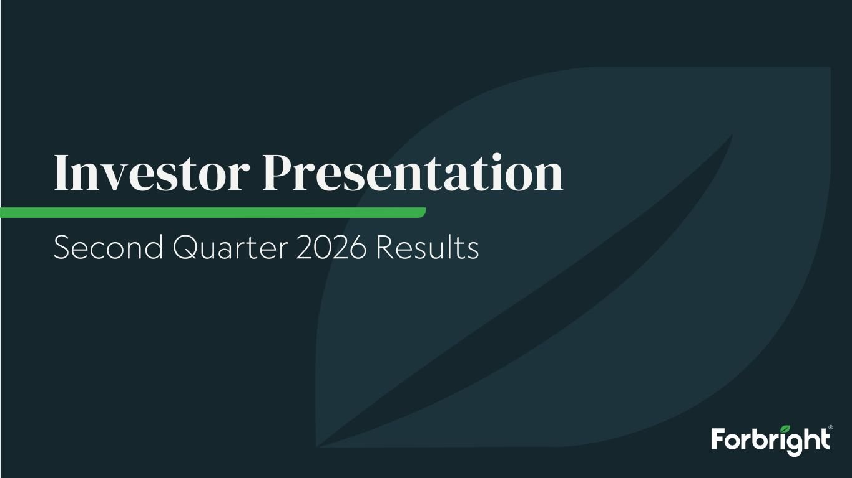
24
Investor Presentation Second Quarter 2026 Results

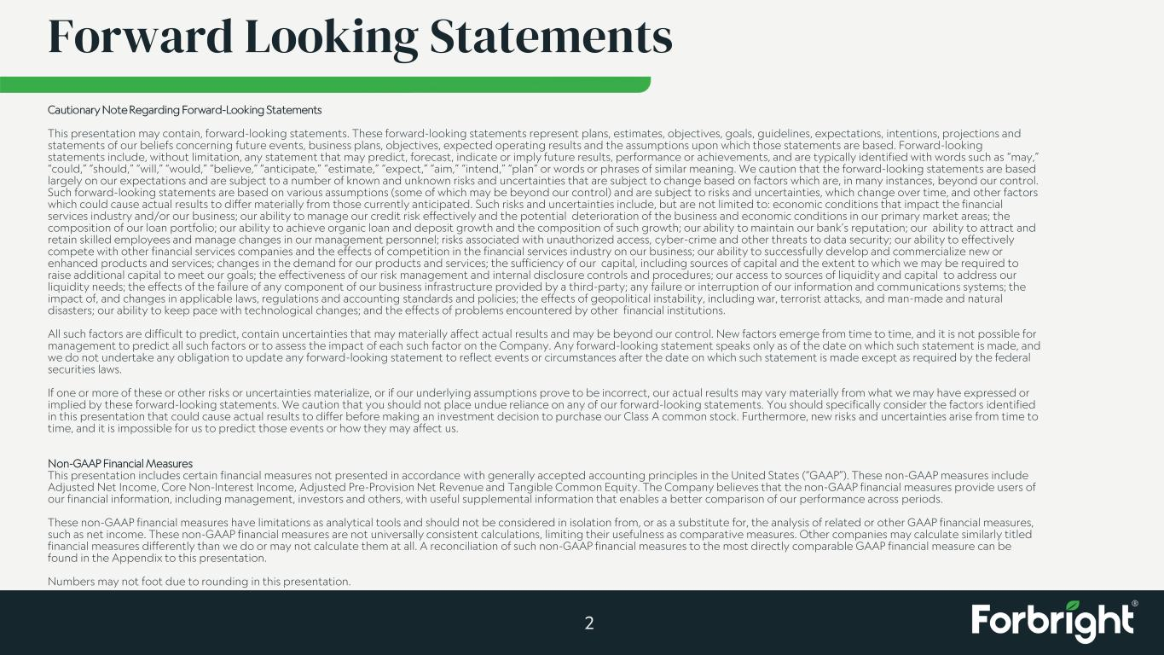
Forward Looking Statements Cautionary Note Regarding Forward-Looking Statements This presentation may contain, forward-looking statements. These forward-looking statements represent plans, estimates, objectives, goals, guidelines, expectations, intentions, projections and statements of our beliefs concerning future events, business plans, objectives, expected operating results and the assumptions upon which those statements are based. Forward-looking statements include, without limitation, any statement that may predict, forecast, indicate or imply future results, performance or achievements, and are typically identified with words such as “may,” “could,” “should,” “will,” “would,” “believe,” “anticipate,” “estimate,” “expect,” “aim,” “intend,” “plan” or words or phrases of similar meaning. We caution that the forward-looking statements are based largely on our expectations and are subject to a number of known and unknown risks and uncertainties that are subject to change based on factors which are, in many instances, beyond our control. Such forward-looking statements are based on various assumptions (some of which may be beyond our control) and are subject to risks and uncertainties, which change over time, and other factors which could cause actual results to differ materially from those currently anticipated. Such risks and uncertainties include, but are not limited to: economic conditions that impact the financial services industry and/or our business; our ability to manage our credit risk effectively and the potential deterioration of the business and economic conditions in our primary market areas; the composition of our loan portfolio; our ability to achieve organic loan and deposit growth and the composition of such growth; our ability to maintain our bank’s reputation; our ability to attract and retain skilled employees and manage changes in our management personnel; risks associated with unauthorized access, cyber-crime and other threats to data security; our ability to effectively compete with other financial services companies and the effects of competition in the financial services industry on our business; our ability to successfully develop and commercialize new or enhanced products and services; changes in the demand for our products and services; the sufficiency of our capital, including sources of capital and the extent to which we may be required to raise additional capital to meet our goals; the effectiveness of our risk management and internal disclosure controls and procedures; our access to sources of liquidity and capital to address our liquidity needs; the effects of the failure of any component of our business infrastructure provided by a third-party; any failure or interruption of our information and communications systems; the impact of, and changes in applicable laws, regulations and accounting standards and policies; the effects of geopolitical instability, including war, terrorist attacks, and man-made and natural disasters; our ability to keep pace with technological changes; and the effects of problems encountered by other financial institutions. All such factors are difficult to predict, contain uncertainties that may materially affect actual results and may be beyond our control. New factors emerge from time to time, and it is not possible for management to predict all such factors or to assess the impact of each such factor on the Company. Any forward-looking statement speaks only as of the date on which such statement is made, and we do not undertake any obligation to update any forward-looking statement to reflect events or circumstances after the date on which such statement is made except as required by the federal securities laws. If one or more of these or other risks or uncertainties materialize, or if our underlying assumptions prove to be incorrect, our actual results may vary materially from what we may have expressed or implied by these forward-looking statements. We caution that you should not place undue reliance on any of our forward-looking statements. You should specifically consider the factors identified in this presentation that could cause actual results to differ before making an investment decision to purchase our Class A common stock. Furthermore, new risks and uncertainties arise from time to time, and it is impossible for us to predict those events or how they may affect us. Non-GAAP Financial Measures This presentation includes certain financial measures not presented in accordance with generally accepted accounting principles in the United States (“GAAP”). These non-GAAP measures include Adjusted Net Income, Core Non-Interest Income, Adjusted Pre-Provision Net Revenue and Tangible Common Equity. The Company believes that the non-GAAP financial measures provide users of our financial information, including management, investors and others, with useful supplemental information that enables a better comparison of our performance across periods. These non-GAAP financial measures have limitations as analytical tools and should not be considered in isolation from, or as a substitute for, the analysis of related or other GAAP financial measures, such as net income. These non-GAAP financial measures are not universally consistent calculations, limiting their usefulness as comparative measures. Other companies may calculate similarly titled financial measures differently than we do or may not calculate them at all. A reconciliation of such non-GAAP financial measures to the most directly comparable GAAP financial measure can be found in the Appendix to this presentation. Numbers may not foot due to rounding in this presentation. 2

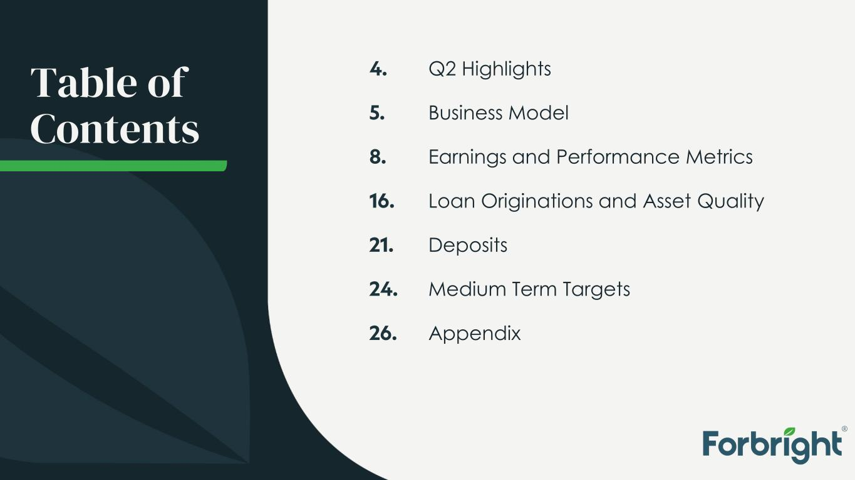
Table of Contents Q2 Highlights Business Model Earnings and Performance Metrics Loan Originations and Asset Quality Deposits Medium Term Targets Appendix 4. 5. 8. 16. 21. 24. 26.

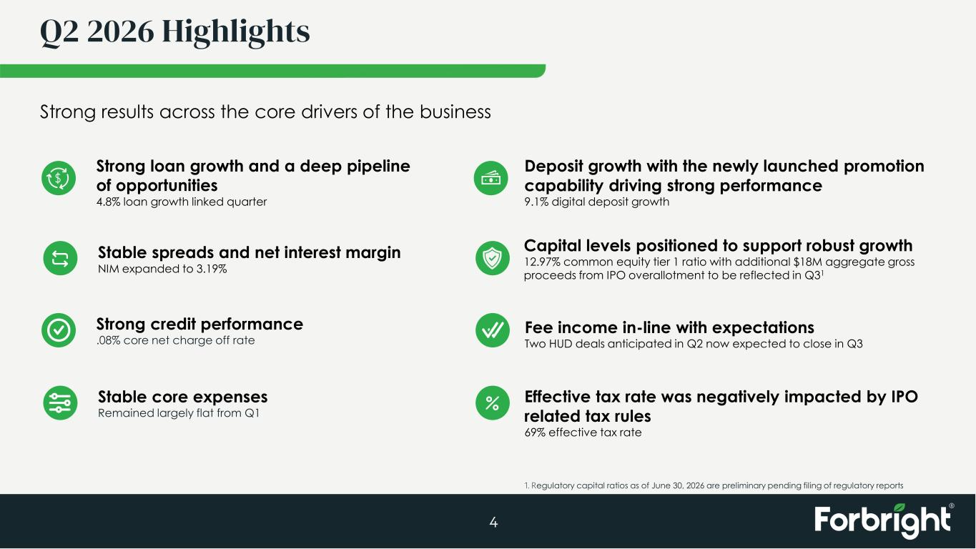
Q2 2026 Highlights 4 Strong results across the core drivers of the business Strong credit performance .08% core net charge off rate Deposit growth with the newly launched promotion capability driving strong performance 9.1% digital deposit growth Effective tax rate was negatively impacted by IPO related tax rules 69% effective tax rate Stable core expenses Remained largely flat from Q1 Fee income in-line with expectations Two HUD deals anticipated in Q2 now expected to close in Q3 Capital levels positioned to support robust growth 12.97% common equity tier 1 ratio with additional $18M aggregate gross proceeds from IPO overallotment to be reflected in Q31 Strong loan growth and a deep pipeline of opportunities 4.8% loan growth linked quarter Stable spreads and net interest margin NIM expanded to 3.19% 1. Regulatory capital ratios as of June 30, 2026 are preliminary pending filing of regulatory reports


5 Business Model

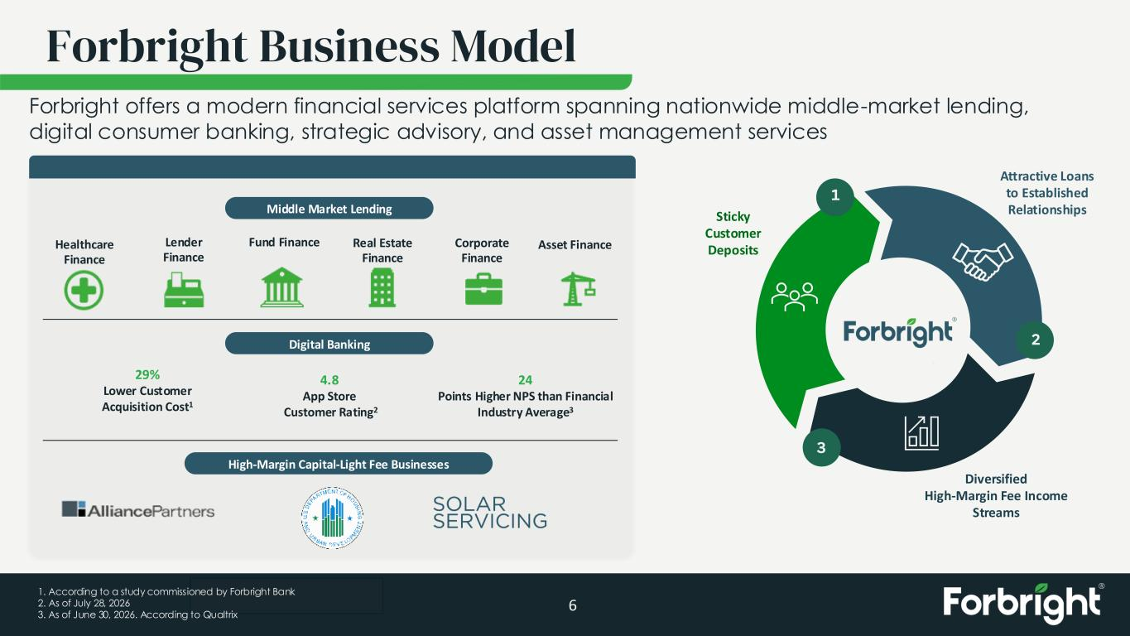
Draft/Deliberative Forbright Business Model 6 29% Lower Customer Acquisition Cost1 4.8 App Store Customer Rating2 24 Points Higher NPS than Financial Industry Average3 Healthcare Finance Corporate Finance Real Estate Finance Middle Market Lending Lender Finance Fund Finance Digital Banking High-Margin Capital-Light Fee Businesses Asset Finance Sticky Customer Deposits Diversified High-Margin Fee Income Streams Attractive Loans to Established Relationships 1 Forbright offers a modern financial services platform spanning nationwide middle-market lending, digital consumer banking, strategic advisory, and asset management services 2 3 1. According to a study commissioned by Forbright Bank 2. As of July 28, 2026 3. As of June 30, 2026. According to Qualtrix

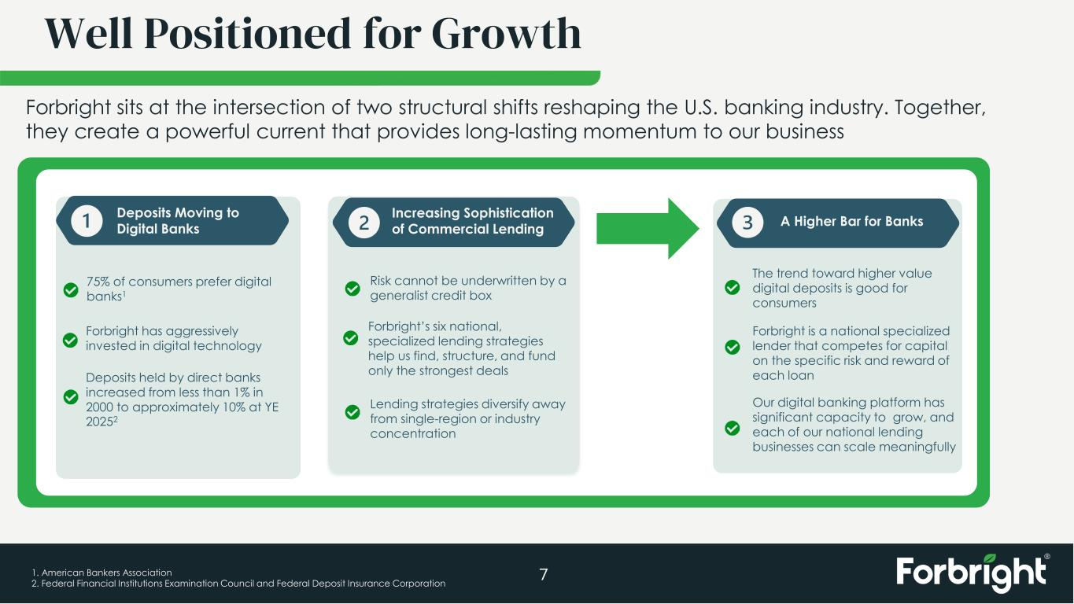
Well Positioned for Growth 7 A Higher Bar for Banks Forbright is a national specialized lender that competes for capital on the specific risk and reward of each loan The trend toward higher value digital deposits is good for consumers Increasing Sophistication of Commercial Lending Risk cannot be underwritten by a generalist credit box Forbright’s six national, specialized lending strategies help us find, structure, and fund only the strongest deals Deposits Moving to Digital Banks Deposits held by direct banks increased from less than 1% in 2000 to approximately 10% at YE 20252 75% of consumers prefer digital banks1 Forbright has aggressively invested in digital technology Lending strategies diversify away from single-region or industry concentration Our digital banking platform has significant capacity to grow, and each of our national lending businesses can scale meaningfully Forbright sits at the intersection of two structural shifts reshaping the U.S. banking industry. Together, they create a powerful current that provides long-lasting momentum to our business 1. American Bankers Association 2. Federal Financial Institutions Examination Council and Federal Deposit Insurance Corporation

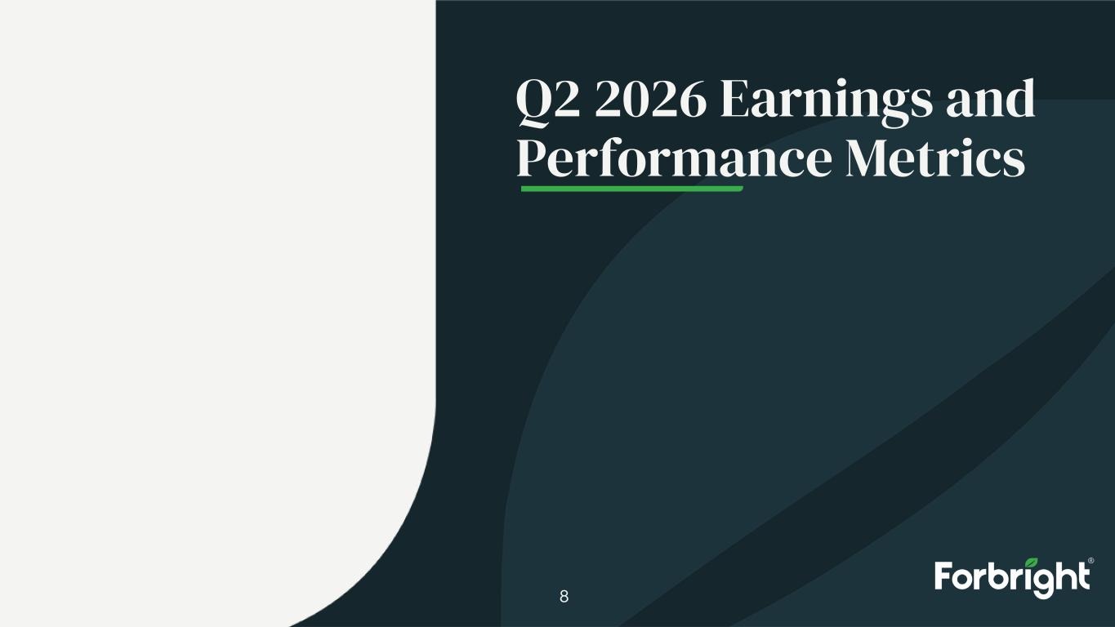
8 Q2 2026 Earnings and Performance Metrics

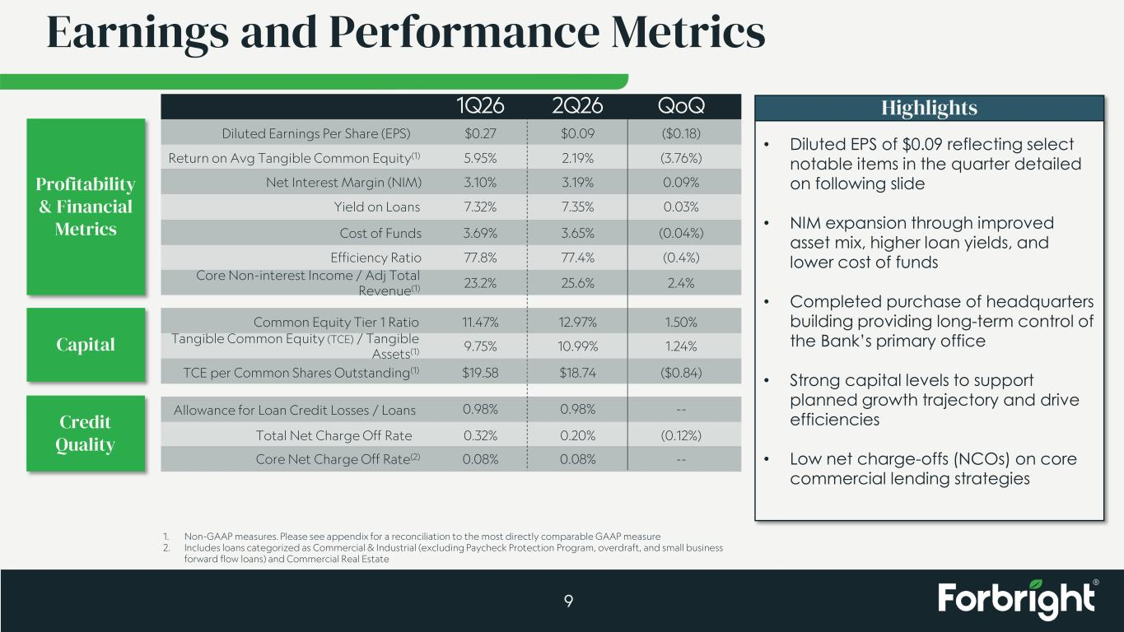
Earnings and Performance Metrics 9 Diluted Earnings Per Share (EPS) Return on Avg Tangible Common Equity(1) Net Interest Margin (NIM) Common Equity Tier 1 Ratio Yield on Loans Cost of Funds Allowance for Loan Credit Losses / Loans Total Net Charge Off Rate Core Net Charge Off Rate(2) Tangible Common Equity (TCE) / Tangible Assets(1) 1Q26 $0.27 5.95% 3.10% 11.47% 7.32% 3.69% 0.98% 0.32% 0.08% 9.75% QoQ ($0.18) (3.76%) 0.09% 1.50% 0.03% (0.04%) -- (0.12%) -- 1.24% 2Q26 $0.09 2.19% 3.19% 12.97% 7.35% 3.65% 0.98% 0.20% 0.08% 10.99% Highlights • Diluted EPS of $0.09 reflecting select notable items in the quarter detailed on following slide • NIM expansion through improved asset mix, higher loan yields, and lower cost of funds • Completed purchase of headquarters building providing long-term control of the Bank’s primary office • Strong capital levels to support planned growth trajectory and drive efficiencies • Low net charge-offs (NCOs) on core commercial lending strategies Efficiency Ratio Core Non-interest Income / Adj Total Revenue(1) 77.8% 23.2% (0.4%) 2.4% 77.4% 25.6% Profitability & Financial Metrics Capital Credit Quality TCE per Common Shares Outstanding(1) $19.58 ($0.84)$18.74 1. Non-GAAP measures. Please see appendix for a reconciliation to the most directly comparable GAAP measure 2. Includes loans categorized as Commercial & Industrial (excluding Paycheck Protection Program, overdraft, and small business forward flow loans) and Commercial Real Estate

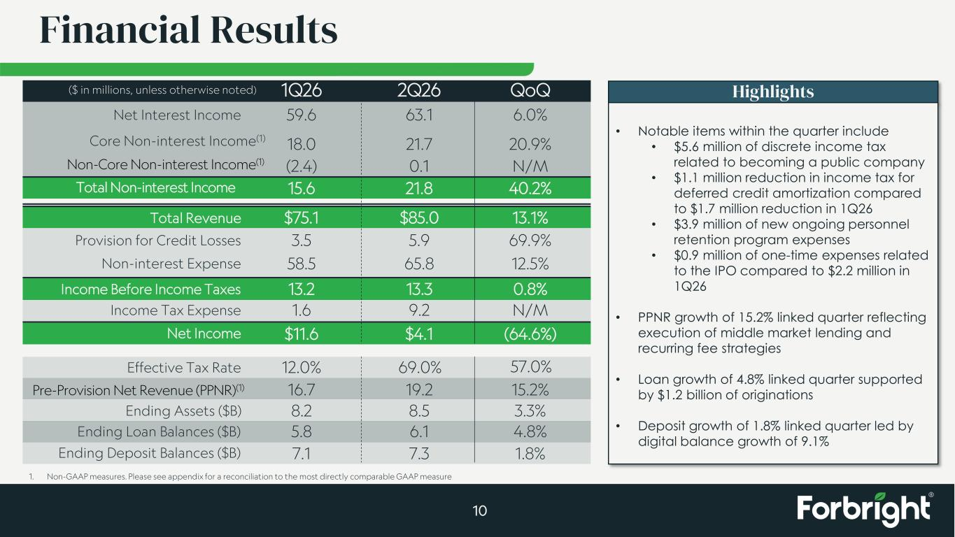
Non-interest Expense 58.5 12.5%65.8 Income Tax Expense 1.6 N/M9.2 Net Income $11.6 (64.6%)$4.1 Total Revenue $75.1 13.1%$85.0 Financial Results 10 ($ in millions, unless otherwise noted) 1Q26 QoQ2Q26 Net Interest Income 59.6 6.0%63.1 (2.4) N/M0.1 Total Non-interest Income 15.6 40.2%21.8 Highlights • Notable items within the quarter include • $5.6 million of discrete income tax related to becoming a public company • $1.1 million reduction in income tax for deferred credit amortization compared to $1.7 million reduction in 1Q26 • $3.9 million of new ongoing personnel retention program expenses • $0.9 million of one-time expenses related to the IPO compared to $2.2 million in 1Q26 • PPNR growth of 15.2% linked quarter reflecting execution of middle market lending and recurring fee strategies • Loan growth of 4.8% linked quarter supported by $1.2 billion of originations • Deposit growth of 1.8% linked quarter led by digital balance growth of 9.1% Core Non-interest Income(1) 18.0 20.9%21.7 Provision for Credit Losses 3.5 69.9%5.9 16.7 15.2%19.2 Income Before Income Taxes 13.2 0.8%13.3 Ending Loan Balances ($B) 5.8 4.8%6.1 Ending Deposit Balances ($B) 7.1 1.8%7.3 Ending Assets ($B) 8.2 3.3%8.5 1. Non-GAAP measures. Please see appendix for a reconciliation to the most directly comparable GAAP measure Effective Tax Rate 12.0% 69.0% 57.0% Non-Core Non-interest Income(1) Pre-Provision Net Revenue (PPNR)(1)

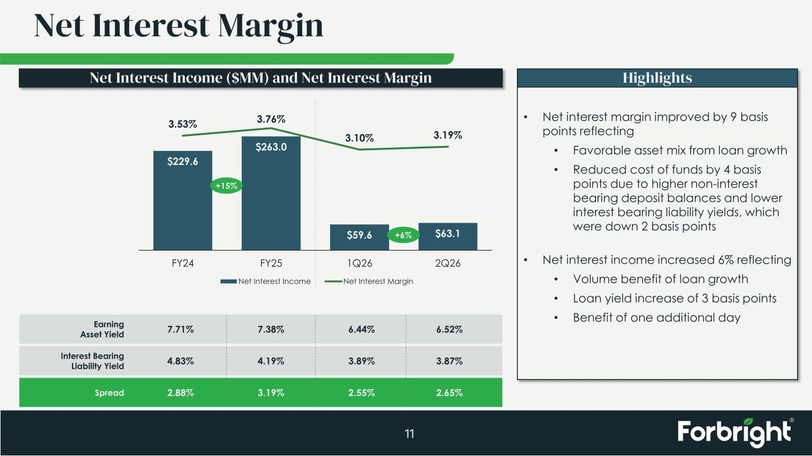
Net Interest Margin 11 HighlightsNet Interest Income ($MM) and Net Interest Margin Earning Asset Yield Interest Bearing Liability Yield Spread 7.71% 4.83% 2.88% 7.38% 4.19% 3.19% 6.44% 3.89% 2.55% 6.52% 3.87% 2.65% • Net interest margin improved by 9 basis points reflecting • Favorable asset mix from loan growth • Reduced cost of funds by 4 basis points due to higher non-interest bearing deposit balances and lower interest bearing liability yields, which were down 2 basis points • Net interest income increased 6% reflecting • Volume benefit of loan growth • Loan yield increase of 3 basis points • Benefit of one additional day $229.6 $263.0 $59.6 $63.1 3.53% 3.76% 3.10% 3.19% FY24 FY25 1Q26 2Q26 Net Interest Income Net Interest Margin +6% +15%

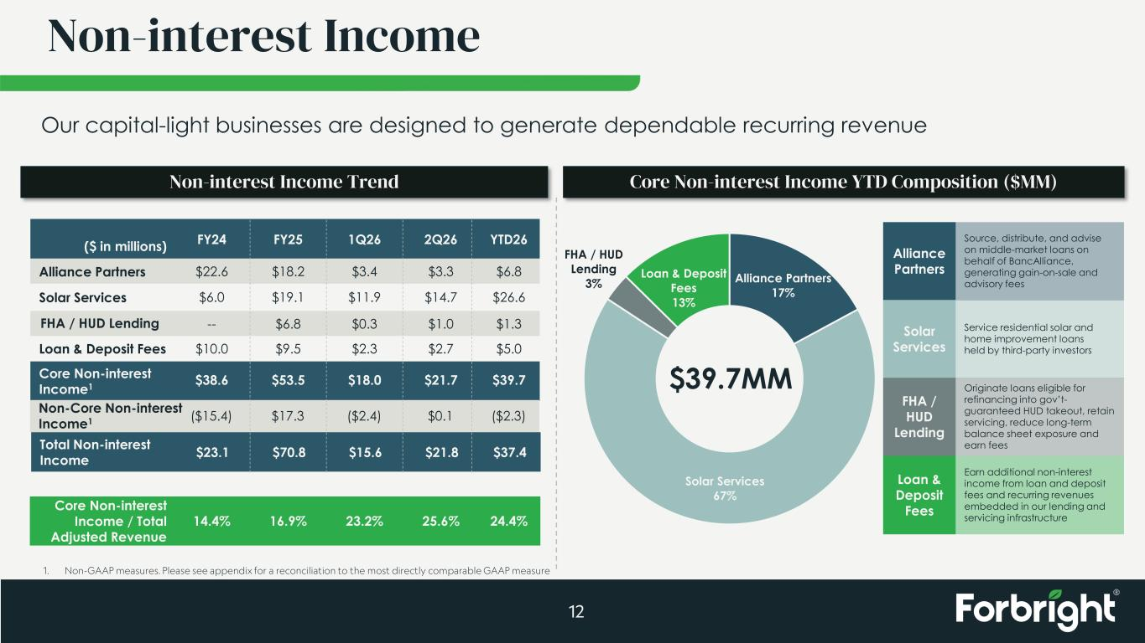
Alliance Partners 17% Solar Services 67% FHA / HUD Lending 3% Loan & Deposit Fees 13% Non-interest Income 12 Our capital-light businesses are designed to generate dependable recurring revenue $39.7MM Alliance Partners Solar Services Loan & Deposit Fees FHA / HUD Lending FY24 FY25 1Q26 2Q26 $22.6 $18.2 $3.4 $3.3 $6.0 $19.1 $11.9 $14.7 -- $6.8 $0.3 $1.0 $10.0 $9.5 $2.3 $2.7 YTD26 $6.8 $26.6 $1.3 $5.0 $38.6 $53.5 $18.0 $21.7 $39.7Core Non-interest Income1 ($ in millions) 14.4% 16.9% 23.2% 25.6% 24.4% Core Non-interest Income / Total Adjusted Revenue Non-interest Income Trend Core Non-interest Income YTD Composition ($MM) Non-Core Non-interest Income1 ($15.4) $17.3 ($2.4) $0.1 ($2.3) $23.1 $70.8 $15.6 $21.8 $37.4Total Non-interest Income Alliance Partners Solar Services FHA / HUD Lending Loan & Deposit Fees Source, distribute, and advise on middle-market loans on behalf of BancAlliance, generating gain-on-sale and advisory fees Service residential solar and home improvement loans held by third-party investors Originate loans eligible for refinancing into gov’t- guaranteed HUD takeout, retain servicing, reduce long-term balance sheet exposure and earn fees Earn additional non-interest income from loan and deposit fees and recurring revenues embedded in our lending and servicing infrastructure 1. Non-GAAP measures. Please see appendix for a reconciliation to the most directly comparable GAAP measure

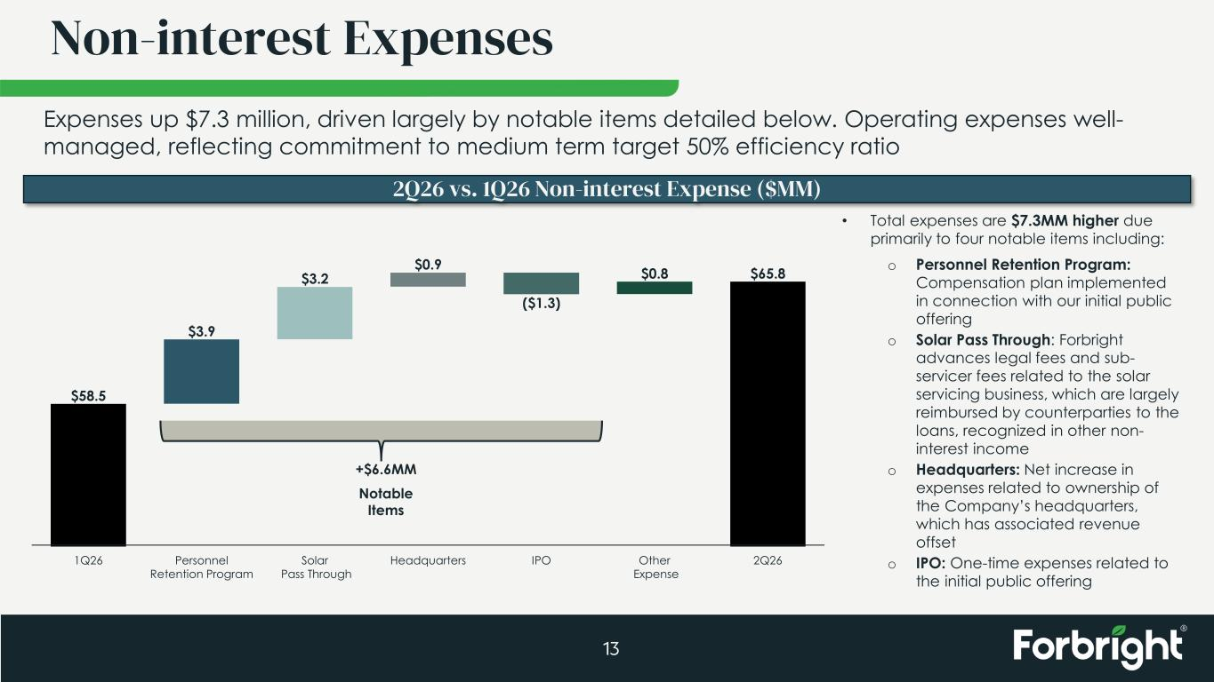
$58.5 $3.9 $3.2 $0.9 ($1.3) $0.8 $65.8 1Q26 Personnel Retention Program Solar Pass Through Headquarters IPO Other Expense 2Q26 Non-interest Expenses 13 Expenses up $7.3 million, driven largely by notable items detailed below. Operating expenses well- managed, reflecting commitment to medium term target 50% efficiency ratio 2Q26 vs. 1Q26 Non-interest Expense ($MM) • Total expenses are $7.3MM higher due primarily to four notable items including: o Personnel Retention Program: Compensation plan implemented in connection with our initial public offering o Solar Pass Through: Forbright advances legal fees and sub- servicer fees related to the solar servicing business, which are largely reimbursed by counterparties to the loans, recognized in other non- interest income o Headquarters: Net increase in expenses related to ownership of the Company’s headquarters, which has associated revenue offset o IPO: One-time expenses related to the initial public offering +$6.6MM Notable Items

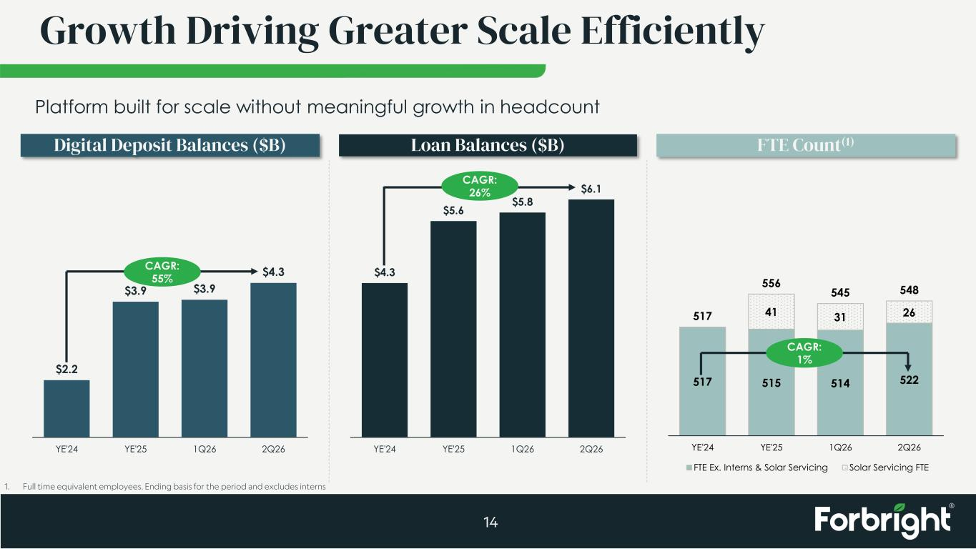
$2.2 $3.9 $3.9 $4.3 YE'24 YE'25 1Q26 2Q26 517 515 514 522 41 31 26517 556 545 548 YE'24 YE'25 1Q26 2Q26 FTE Ex. Interns & Solar Servicing Solar Servicing FTE Growth Driving Greater Scale Efficiently 14 Platform built for scale without meaningful growth in headcount Digital Deposit Balances ($B) Loan Balances ($B) FTE Count(1) CAGR: 55% CAGR: 26% 1. Full time equivalent employees. Ending basis for the period and excludes interns CAGR: 1% $4.3 $5.6 $5.8 $6.1 YE'24 YE'25 1Q26 2Q26

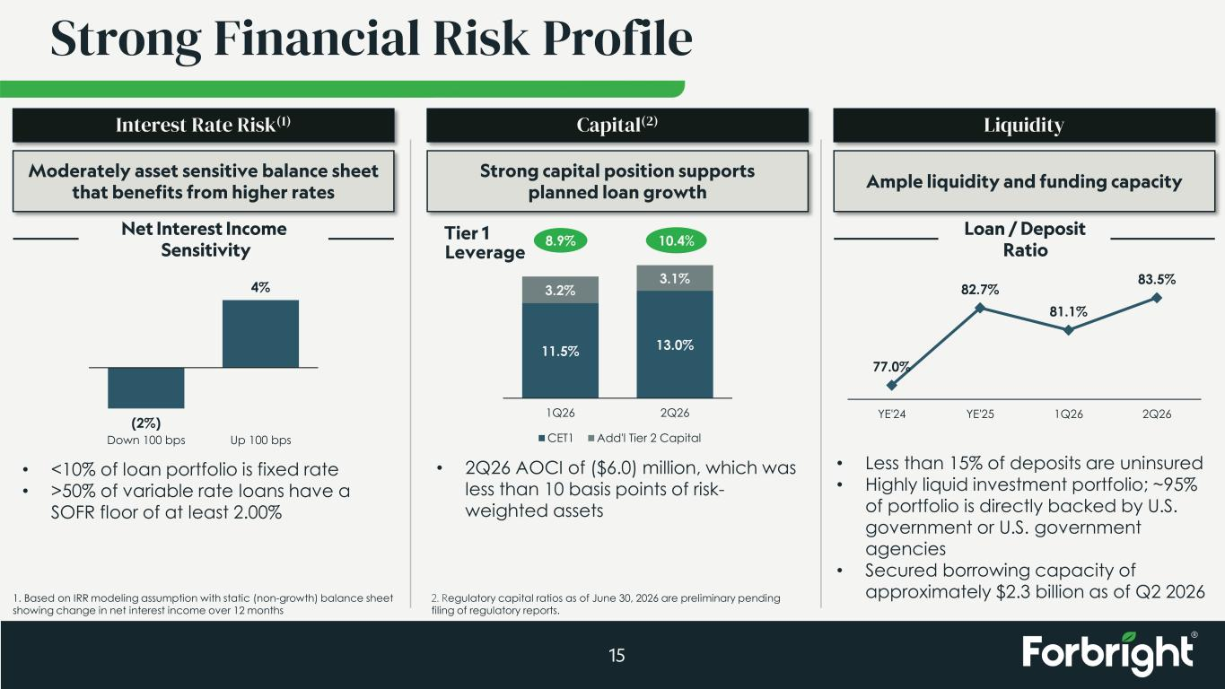
Strong Financial Risk Profile 15 11.5% 13.0% 3.2% 3.1% 1Q26 2Q26 CET1 Add'l Tier 2 Capital Capital(2) Strong capital position supports planned loan growth • 2Q26 AOCI of ($6.0) million, which was less than 10 basis points of risk- weighted assets Tier 1 Leverage 8.9% 10.4% 2. Regulatory capital ratios as of June 30, 2026 are preliminary pending filing of regulatory reports. Liquidity Ample liquidity and funding capacity • Less than 15% of deposits are uninsured • Highly liquid investment portfolio; ~95% of portfolio is directly backed by U.S. government or U.S. government agencies • Secured borrowing capacity of approximately $2.3 billion as of Q2 2026 Loan / Deposit Ratio 77.0% 82.7% 81.1% 83.5% YE'24 YE'25 1Q26 2Q26 1. Based on IRR modeling assumption with static (non-growth) balance sheet showing change in net interest income over 12 months Interest Rate Risk(1) Moderately asset sensitive balance sheet that benefits from higher rates • <10% of loan portfolio is fixed rate • >50% of variable rate loans have a SOFR floor of at least 2.00% (2%) 4% Down 100 bps Up 100 bps Net Interest Income Sensitivity

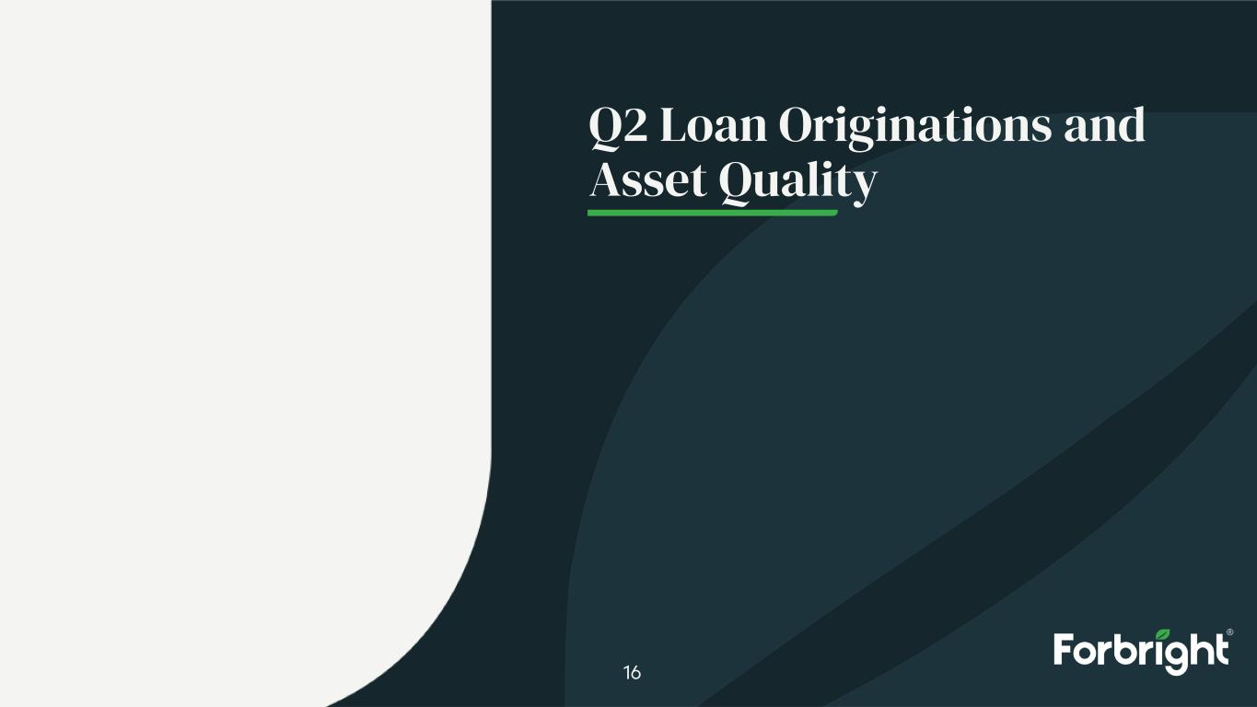
Q2 Loan Originations and Asset Quality 16

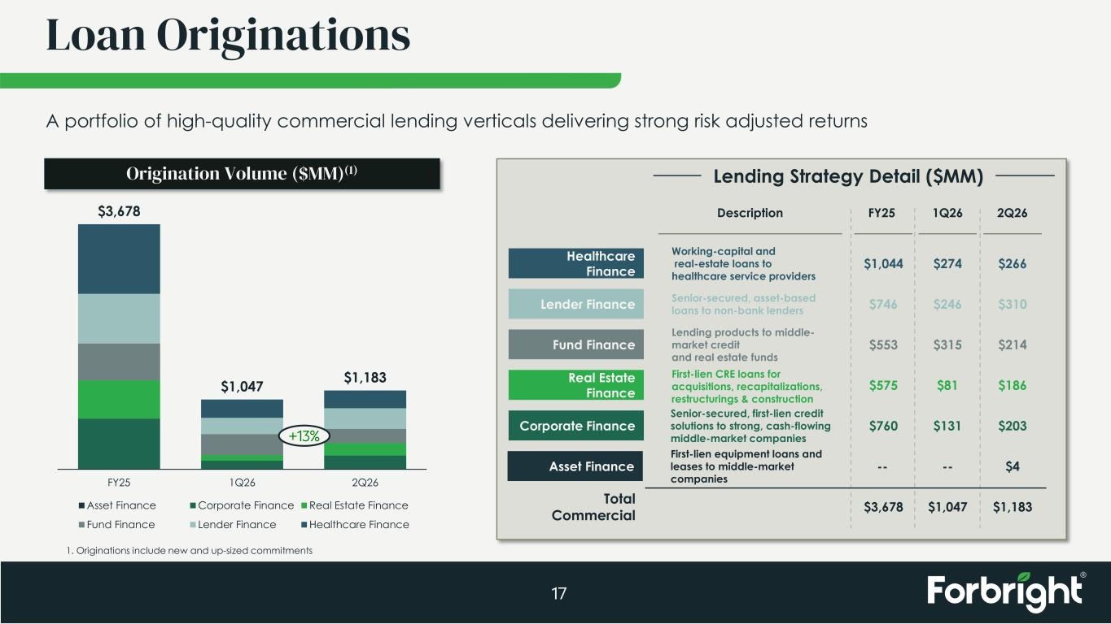
Loan Originations 17 Origination Volume ($MM)(1) Lender Finance Fund Finance Real Estate Finance Corporate Finance Healthcare Finance Description Lending Strategy Detail ($MM) FY25 1Q26 2Q26 Total Commercial Working-capital and real-estate loans to healthcare service providers Senior-secured, asset-based loans to non-bank lenders Lending products to middle- market credit and real estate funds First-lien CRE loans for acquisitions, recapitalizations, restructurings & construction Senior-secured, first-lien credit solutions to strong, cash-flowing middle-market companies $1,044 $746 $553 $575 $760 $3,678 $274 $246 $315 $81 $131 $1,047 $266 $310 $214 $186 $203 $1,183 Asset Finance First-lien equipment loans and leases to middle-market companies -- -- $4 A portfolio of high-quality commercial lending verticals delivering strong risk adjusted returns $3,678 $1,047 $1,183 FY25 1Q26 2Q26 Asset Finance Corporate Finance Real Estate Finance Fund Finance Lender Finance Healthcare Finance +13% 1. Originations include new and up-sized commitments

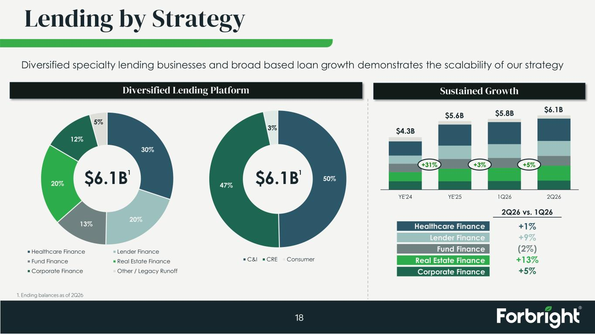
50% 47% 3% C&I CRE Consumer YE'24 YE'25 1Q26 2Q26 Lending by Strategy 18 Diversified Lending Platform Sustained Growth $4.3B $5.6B $5.8B $6.1B +31% +3% +5% Lender Finance Fund Finance Real Estate Finance Corporate Finance Healthcare Finance 2Q26 vs. 1Q26 +1% +9% (2%) +13% +5% 1. Ending balances as of 2Q26 Diversified specialty lending businesses and broad based loan growth demonstrates the scalability of our strategy 30% 20%13% 20% 12% 5% Healthcare Finance Lender Finance Fund Finance Real Estate Finance Corporate Finance Other / Legacy Runoff $6.1B1 $6.1B1

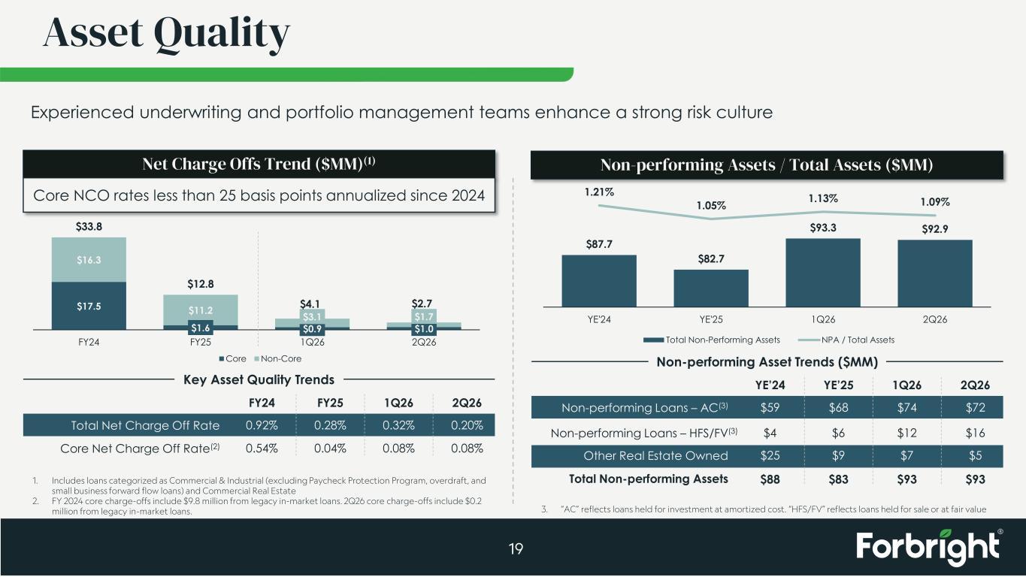
$17.5 $1.6 $0.9 $1.0 $16.3 $11.2 $3.1 $1.7 $33.8 $12.8 $4.1 $2.7 FY24 FY25 1Q26 2Q26 Core Non-Core YE’24 YE’25 1Q26 2Q26 FY24 FY25 1Q26 2Q26 Asset Quality 19 Key Asset Quality Trends Total Net Charge Off Rate Core Net Charge Off Rate(2) 0.92% 0.28% 0.32% 0.20% 0.54% 0.04% 0.08% 0.08% Non-performing Asset Trends ($MM) Non-performing Loans – AC(3) Other Real Estate Owned Total Non-performing Assets $59 $68 $74 $72 $25 $9 $7 $5 $88 $83 $93 $93 Net Charge Offs Trend ($MM)(1) Non-performing Assets / Total Assets ($MM) $87.7 $82.7 $93.3 $92.9 1.21% 1.05% 1.13% 1.09% YE'24 YE'25 1Q26 2Q26 Total Non-Performing Assets NPA / Total Assets 1. Includes loans categorized as Commercial & Industrial (excluding Paycheck Protection Program, overdraft, and small business forward flow loans) and Commercial Real Estate 2. FY 2024 core charge-offs include $9.8 million from legacy in-market loans. 2Q26 core charge-offs include $0.2 million from legacy in-market loans. Experienced underwriting and portfolio management teams enhance a strong risk culture $4 $6 $12 $16Non-performing Loans – HFS/FV(3) 3. “AC” reflects loans held for investment at amortized cost. “HFS/FV” reflects loans held for sale or at fair value Core NCO rates less than 25 basis points annualized since 2024

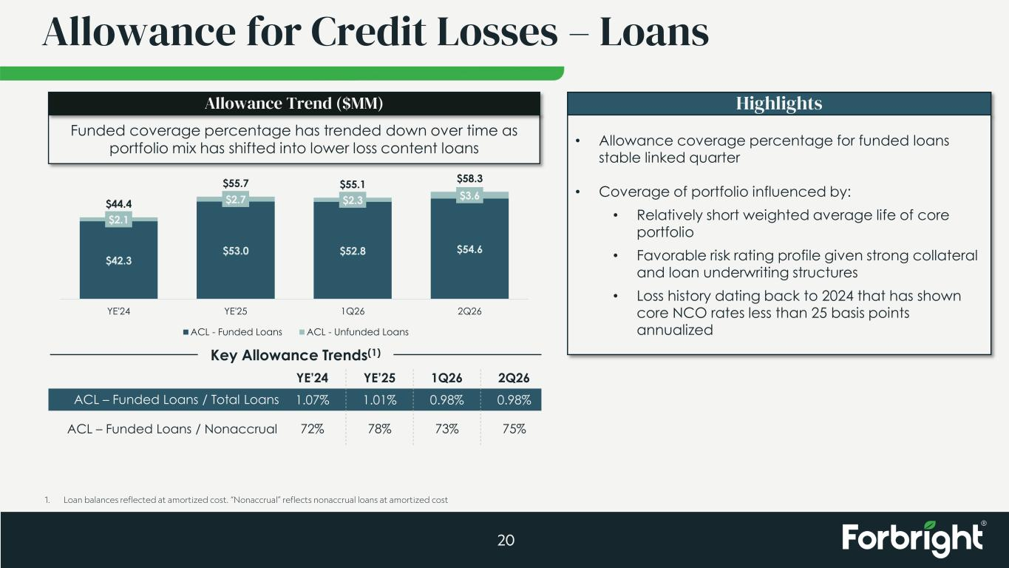
YE’24 YE’25 1Q26 2Q26 Allowance for Credit Losses – Loans 20 Key Allowance Trends(1) ACL – Funded Loans / Total Loans ACL – Funded Loans / Nonaccrual 1.07% 1.01% 0.98% 0.98% 72% 78% 73% 75% Highlights • Allowance coverage percentage for funded loans stable linked quarter • Coverage of portfolio influenced by: • Relatively short weighted average life of core portfolio • Favorable risk rating profile given strong collateral and loan underwriting structures • Loss history dating back to 2024 that has shown core NCO rates less than 25 basis points annualized Funded coverage percentage has trended down over time as portfolio mix has shifted into lower loss content loans Allowance Trend ($MM) 1. Loan balances reflected at amortized cost. “Nonaccrual” reflects nonaccrual loans at amortized cost $42.3 $53.0 $52.8 $54.6 $2.1 $2.7 $2.3 $3.6 $44.4 $55.7 $55.1 $58.3 YE'24 YE'25 1Q26 2Q26 ACL - Funded Loans ACL - Unfunded Loans


Deposits 21

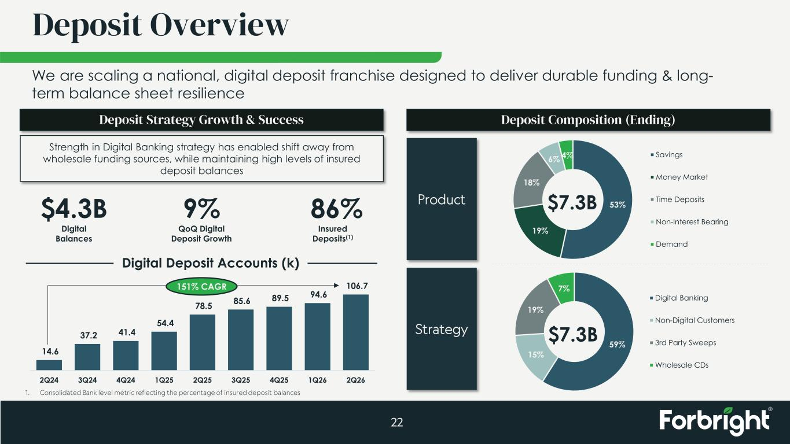
59% 15% 19% 7% Digital Banking Non-Digital Customers 3rd Party Sweeps Wholesale CDs 14.6 37.2 41.4 54.4 78.5 85.6 89.5 94.6 106.7 2Q24 3Q24 4Q24 1Q25 2Q25 3Q25 4Q25 1Q26 2Q26 Deposit Overview 22 Deposit Strategy Growth & Success Strength in Digital Banking strategy has enabled shift away from wholesale funding sources, while maintaining high levels of insured deposit balances $4.3B Digital Balances 86% Insured Deposits(1) Digital Deposit Accounts (k) 151% CAGR Deposit Composition (Ending) Product Strategy $7.3B 9% QoQ Digital Deposit Growth We are scaling a national, digital deposit franchise designed to deliver durable funding & long- term balance sheet resilience 53% 19% 18% 6% 4% Savings Money Market Time Deposits Non-Interest Bearing Demand $7.3B 1. Consolidated Bank level metric reflecting the percentage of insured deposit balances

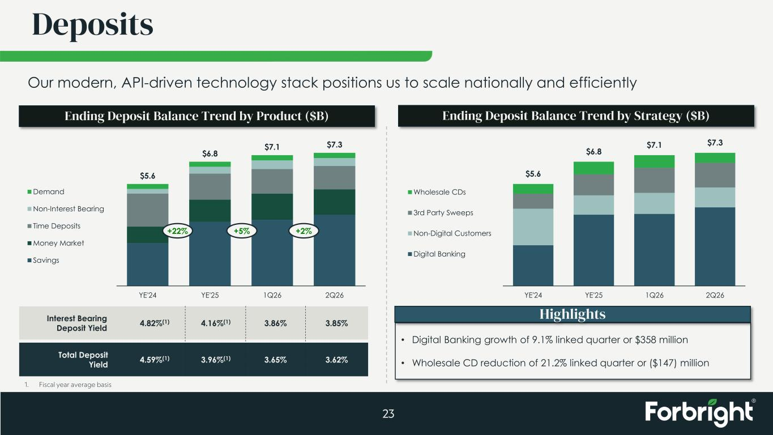
Deposits 23 Ending Deposit Balance Trend by Product ($B) Interest Bearing Deposit Yield Total Deposit Yield 4.82%(1) 4.16%(1) 3.86% 3.85% 4.59%(1) 3.96%(1) 3.65% 3.62% Ending Deposit Balance Trend by Strategy ($B) • Digital Banking growth of 9.1% linked quarter or $358 million • Wholesale CD reduction of 21.2% linked quarter or ($147) million Our modern, API-driven technology stack positions us to scale nationally and efficiently $5.6 $6.8 $7.1 $7.3 YE'24 YE'25 1Q26 2Q26 Demand Non-Interest Bearing Time Deposits Money Market Savings +22% +5% +2% $5.6 $6.8 $7.1 $7.3 YE'24 YE'25 1Q26 2Q26 Wholesale CDs 3rd Party Sweeps Non-Digital Customers Digital Banking 1. Fiscal year average basis Highlights


Medium Term Targets 24

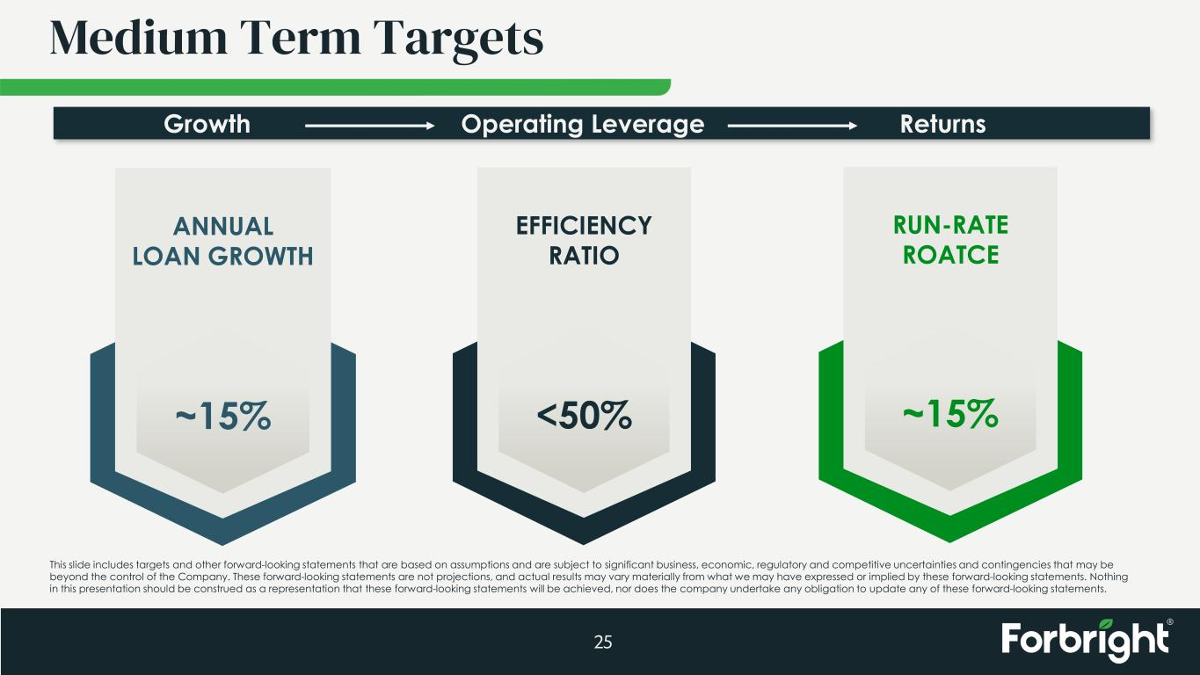
Medium Term Targets 25 ANNUAL LOAN GROWTH ~15% EFFICIENCY RATIO <50% RUN-RATE ROATCE ~15% ReturnsOperating LeverageGrowth This slide includes targets and other forward-looking statements that are based on assumptions and are subject to significant business, economic, regulatory and competitive uncertainties and contingencies that may be beyond the control of the Company. These forward-looking statements are not projections, and actual results may vary materially from what we may have expressed or implied by these forward-looking statements. Nothing in this presentation should be construed as a representation that these forward-looking statements will be achieved, nor does the company undertake any obligation to update any of these forward-looking statements.


Appendix 26

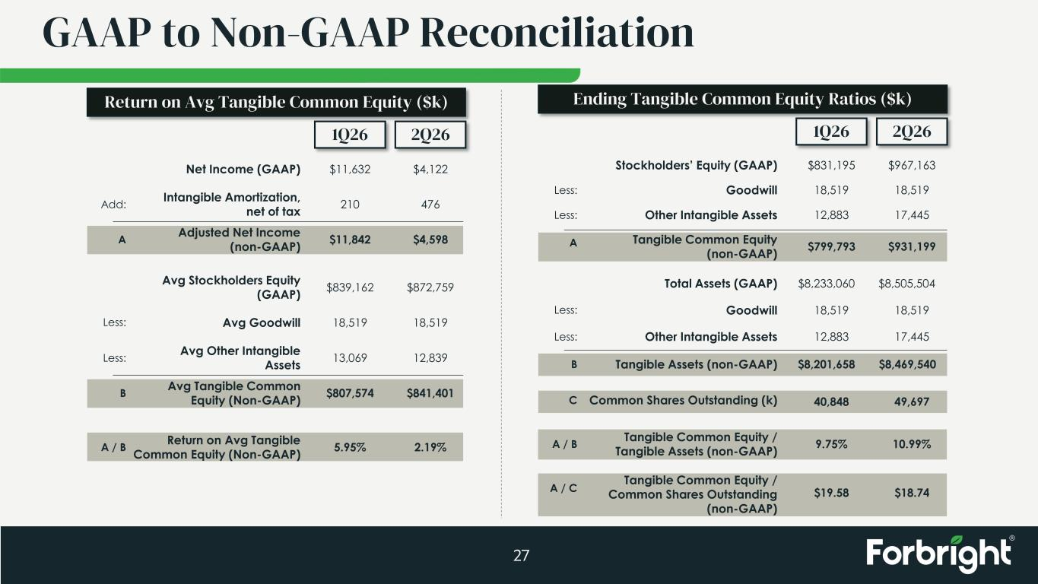
GAAP to Non-GAAP Reconciliation 27 1Q26 2Q26 Stockholders’ Equity (GAAP) $831,195 $967,163 Total Assets (GAAP) $8,233,060 $8,505,504 Tangible Common Equity / Tangible Assets (non-GAAP) 9.75% 10.99% Goodwill 18,519 18,519Less: Goodwill 18,519 18,519Less: Other Intangible Assets 12,883 17,445Less: Tangible Common Equity (non-GAAP) $799,793 $931,199A Tangible Assets (non-GAAP) $8,201,658 $8,469,540B A / B Ending Tangible Common Equity Ratios ($k) Other Intangible Assets 12,883 17,445Less: Common Shares Outstanding (k) 40,848 49,697C Tangible Common Equity / Common Shares Outstanding (non-GAAP) $19.58 $18.74A / C 1Q26 2Q26 Net Income (GAAP) Intangible Amortization, net of tax Adjusted Net Income (non-GAAP) $11,632 210 $11,842 $4,122 476 $4,598 Avg Stockholders Equity (GAAP) $839,162 $872,759 Avg Goodwill 18,519 18,519 Avg Other Intangible Assets 13,069 12,839 Avg Tangible Common Equity (Non-GAAP) $807,574 $841,401 Return on Avg Tangible Common Equity (Non-GAAP) 5.95% 2.19% Add: Less: Less: A B A / B Return on Avg Tangible Common Equity ($k)

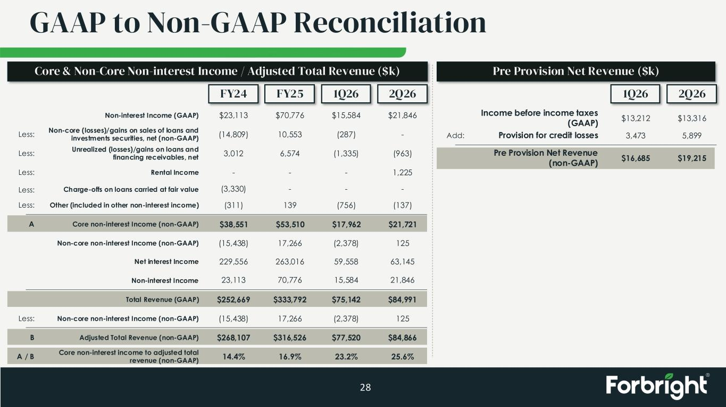
GAAP to Non-GAAP Reconciliation 28 FY24 FY25 1Q26 2Q26 Non-interest Income (GAAP) Non-core (losses)/gains on sales of loans and investments securities, net (non-GAAP) Unrealized (losses)/gains on loans and financing receivables, net Rental Income Other (included in other non-interest income) Core non-interest Income (non-GAAP) Non-core non-interest Income (non-GAAP) $23,113 $70,776 Net interest Income Non-interest Income Total Revenue (GAAP) Non-core non-interest Income (non-GAAP) Adjusted Total Revenue (non-GAAP) Core non-interest income to adjusted total revenue (non-GAAP) $15,584 $21,846 (14,809) 10,553 (287) - 3,012 6,574 (1,335) (963) - - - 1,225 Less: Less: Less: Less: (311) 139 (756) (137) $38,551 $53,510 $17,962 $21,721 (15,438) 17,266 (2,378) 125 229,556 263,016 59,558 63,145 23,113 70,776 15,584 21,846 $252,669 $333,792 $75,142 $84,991 (15,438) 17,266 (2,378) 125 $268,107 $316,526 $77,520 $84,866 Less: A B A / B 14.4% 16.9% 23.2% 25.6% Core & Non-Core Non-interest Income / Adjusted Total Revenue ($k) 1Q26 2Q26 Income before income taxes (GAAP) $13,212 $13,316 Provision for credit losses 3,473 5,899Add: Pre Provision Net Revenue (non-GAAP) $16,685 $19,215 Pre Provision Net Revenue ($k) Less: Charge-offs on loans carried at fair value (3,330) - - -

